COVENTRY UNIVERSITY
School of Computing, Mathematics and Data Sciences

ST7071CEM — Information Retrieval

March Intake 2026
Coursework CW (Regular)

Vertical Search Engine & Document Clustering System

Student Name: Rohit Jha
Student ID: 11782276
Programme: MSc Data Science & Computational Intelligence
Academic Year: 2025/2026
Module Code: ST7071CEM

Table of Contents
[Right-click and select "Update Field"]

List of Figures
[Right-click and select "Update Field"]

List of Tables
[Right-click and select "Update Field"]

Table of Abbreviations
Abbreviation | Full Form | Description
API | Application Programming Interface | A set of protocols for building and integrating application software.
BFS | Breadth-First Search | A traversal strategy for crawling web pages level by level.
CSS | Cascading Style Sheets | Stylesheet language for describing the presentation of HTML documents.
GUI | Graphical User Interface | The visual dashboard through which users interact with the system.
HTML | HyperText Markup Language | Standard markup language for creating web pages.
HTTP | HyperText Transfer Protocol | Application protocol for distributed information systems.
IDF | Inverse Document Frequency | Weighting factor that reduces the importance of common terms.
IR | Information Retrieval | The discipline of finding relevant information from a corpus.
JSON | JavaScript Object Notation | Lightweight format for storing structured publication data.
K-Means | K-Means Clustering | Unsupervised ML algorithm that partitions data into K groups.
ML | Machine Learning | A branch of AI focused on learning from data.
NLTK | Natural Language Toolkit | Python library for NLP text processing tasks.
NoSQL | Not Only SQL | Non-relational database system for flexible schema storage.
PCA | Principal Component Analysis | Dimensionality reduction technique for data visualisation.
REST | Representational State Transfer | Architectural style for designing networked applications.
TF | Term Frequency | Number of times a term appears in a document.
TF-IDF | Term Frequency-Inverse Document Frequency | Ranking model used to determine document relevance.
URL | Uniform Resource Locator | The address of a resource on the World Wide Web.
VSM | Vector Space Model | An algebraic model for representing text documents as vectors.
Table 1. List of abbreviations used in this report.

1. Introduction
Information Retrieval (IR) is the discipline concerned with the representation, storage, organisation, and provision of access to information items. The fundamental objective of an IR system is to satisfy a user's information need by locating and ranking documents according to their estimated relevance to a given query. Modern search engines — from web-scale systems such as Google to specialised academic repositories such as Google Scholar — are practical instantiations of IR principles.
This project establishes a comprehensive information retrieval solution comprising two distinct but complementary tasks. The first task is the development of a vertical search engine that is comparable to Google Scholar, but strictly specialised in retrieving publications authored by members of Coventry University's Centre for Healthcare and Community Transformation. Vertical search engines focus their crawling and indexing scope on a specific domain, allowing for higher precision and the exploitation of domain-specific metadata. This component crawls the Coventry University PurePortal, gathers profiles and publications, processes the text, and provides a Vector Space Model (VSM) using TF-IDF and cosine similarity to rank search results.
The second task complements the retrieval system by implementing a document clustering and classification system. Document clustering is an unsupervised machine learning technique that groups a collection of documents into clusters based on content similarity. Using the established BBC News dataset, this component processes text into TF-IDF vectors and applies K-Means clustering (K=3) to automatically categorise documents into Economics, Entertainment, and Politics. A trained classifier allows users to submit new documents and assigns them to the appropriate cluster based on Euclidean distance.
Both systems are fully integrated into a unified Graphical User Interface (GUI) built with modern web technologies, providing a seamless experience for searching academic literature and classifying news documents. The following sections detail the implementation of the individual components that make up this architecture, including the crawler, indexer, query processor, and classification models.

2. Conceptual Architecture

2.1 Task 1: Vertical Search Engine Pipeline
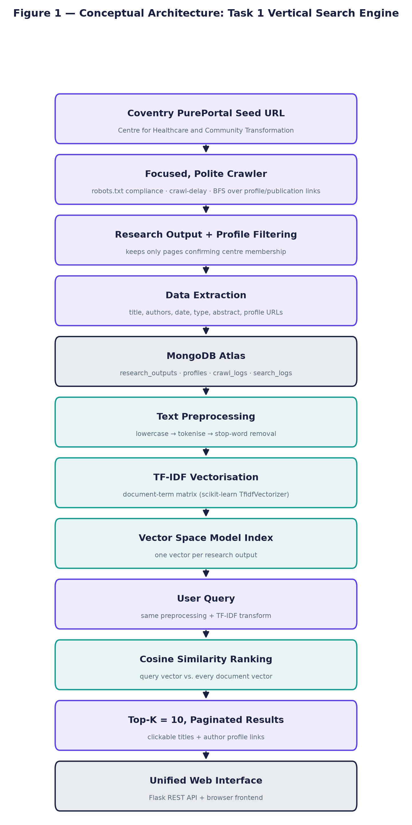
Figure 1. IR Architecture: Vertical Search Engine Pipeline.
The vertical search engine pipeline begins at the PurePortal seed URL, where a polite web crawler discovers research-output and academic-profile pages. Extracted metadata is persisted to a MongoDB database. The stored content undergoes text preprocessing, followed by TF-IDF vectorisation to form the Vector Space Model index. User queries are preprocessed similarly and compared against the index using cosine similarity. The results are returned via a REST API to the frontend interface.

2.2 Task 2: Document Clustering Pipeline
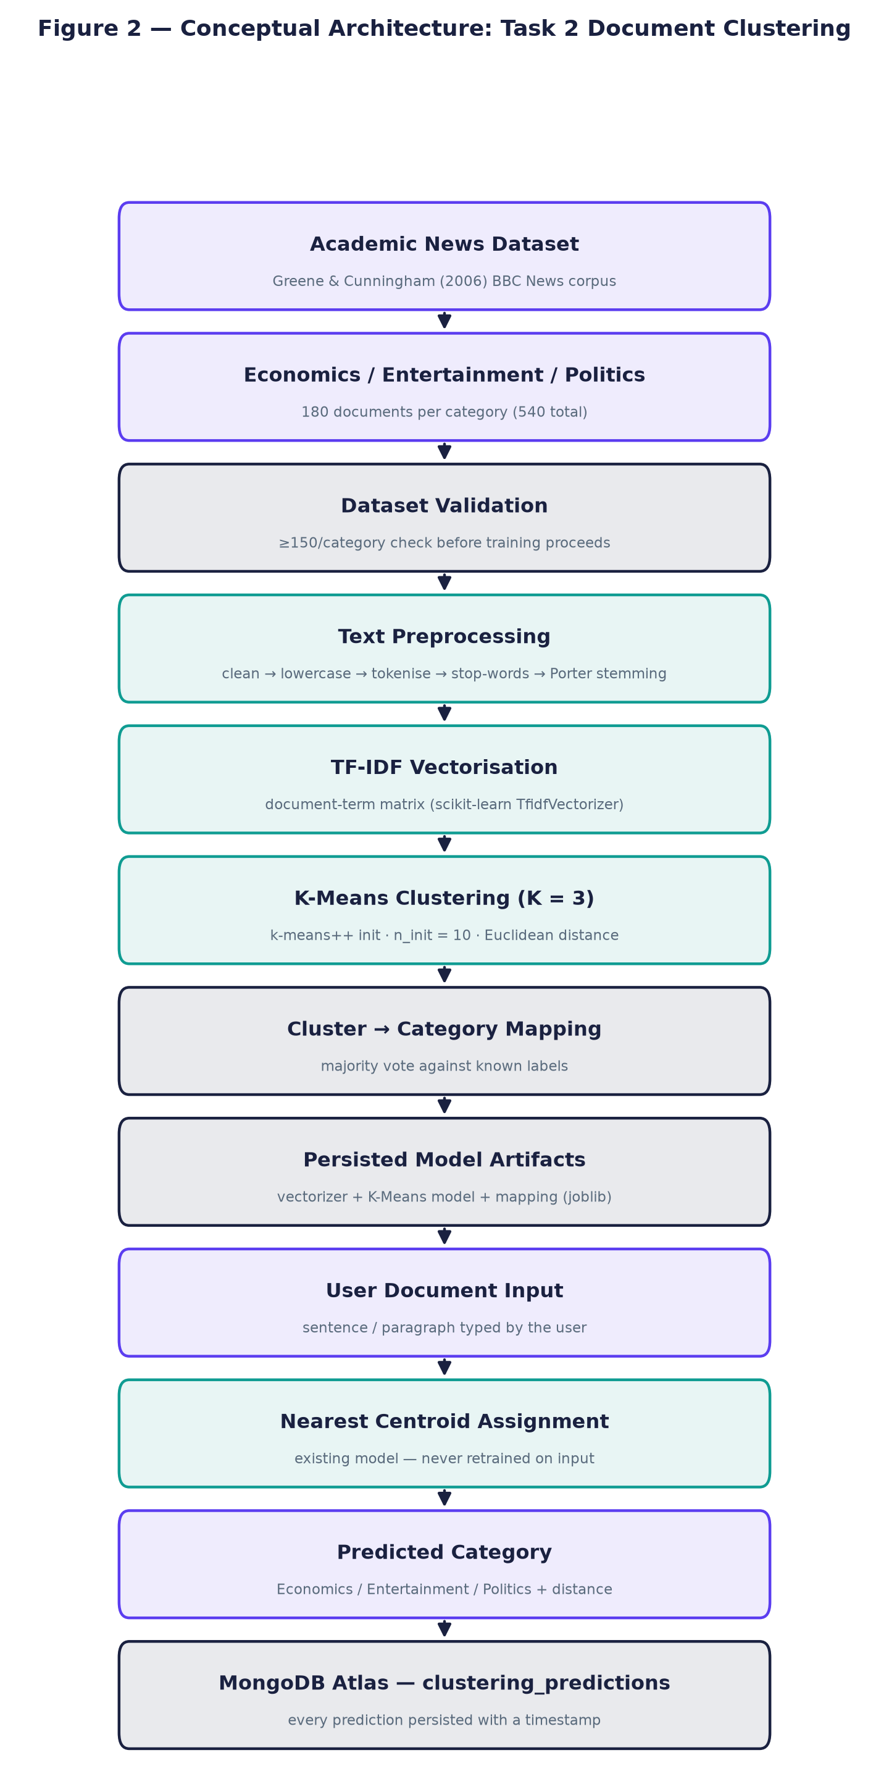
Figure 2. Document Clustering Pipeline.
The document clustering pipeline processes the BBC News dataset through comprehensive preprocessing (including stemming) to construct a TF-IDF matrix. K-Means clustering (K=3) groups the documents, and cluster IDs are mapped to category labels (Economics, Entertainment, Politics) using majority voting. The trained model classifies new user documents by calculating the distance to the established centroids.

2.3 Technology Stack
Component | Technology | Purpose
Backend Framework | Python Flask | REST API serving
Web Crawler | Requests + BeautifulSoup | HTML fetching and parsing
Database | MongoDB Atlas (NoSQL) | Document storage
TF-IDF Vectoriser | scikit-learn | Text-to-vector transformation
Clustering | scikit-learn KMeans | Unsupervised document grouping
Stemming | NLTK Porter Stemmer | Word normalisation (Task 2)
Visualisation | Matplotlib + PCA | 2D cluster projection
Frontend | HTML, CSS, JavaScript | User interface
Scheduling | APScheduler | Automated periodic crawling
Table 2. Technology stack used across both tasks.

3. Crawler Component
A web crawler, often known as a spider, is a software script that browses the internet in a systematic manner to identify and index web pages (Gillis, 2022). In this system, the crawler component is specifically designed to target the Coventry University PurePortal. It is a focused crawler that begins its traversal at the Centre for Healthcare and Community Transformation seed page.

3.1 Crawling Strategy (Breadth-First Search)
The crawler implements a breadth-first search (BFS) strategy. It identifies links to individual research outputs and academic profiles, verifying that the target page belongs to the correct department before extraction. The script utilizes the requests and BeautifulSoup libraries to fetch and parse HTML content.

3.2 Politeness: robots.txt Compliance
To ensure ethical and responsible crawling, the component rigorously adheres to the rules specified in the robots.txt file of the target domain, as mandated by the coursework brief. This is implemented in a dedicated robots_check.py module which utilises Python's standard urllib.robotparser to:
1. Verify whether each URL path is permissible before any HTTP request is made.
2. Honour the published Crawl-Delay of 5 seconds between consecutive requests.
3. Respect all Disallow rules (e.g., RSS export and XLS export URLs are blocked).
The following code excerpt from robots_check.py demonstrates the robots.txt parser:
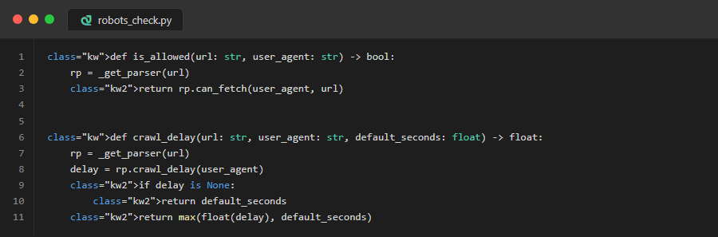
Figure 3. robots_check.py — robots.txt compliance functions.
Every request passes through the polite_get() function in http_client.py, which enforces the robots.txt check before any network call is made:
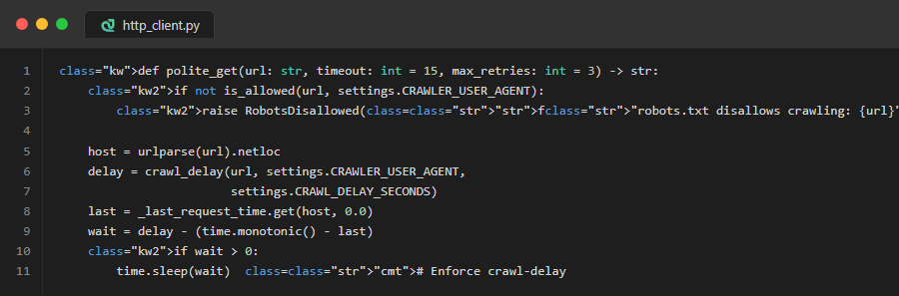
Figure 4. http_client.py — Polite HTTP client enforcing crawl-delay.
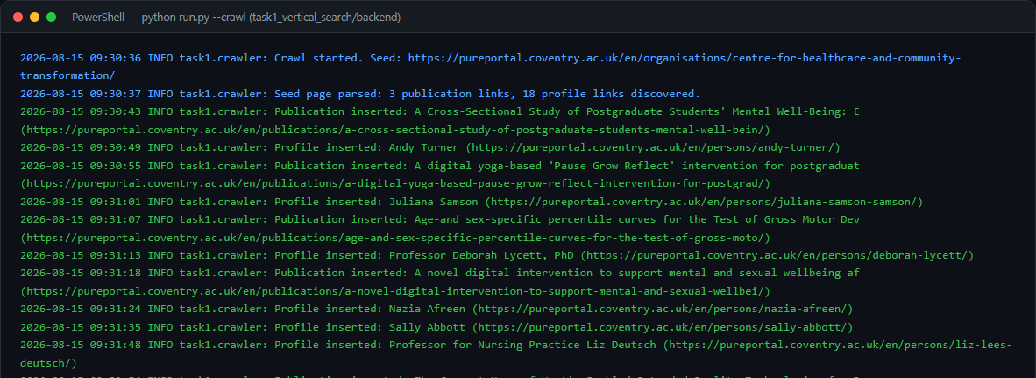
Figure 5. Terminal output of the crawler execution.

3.3 Automated Scheduling
To ensure the search index remains up-to-date with newly published research, the crawler incorporates an automated scheduling component using the APScheduler library. The schedule is configured to execute a full crawl every three months, running entirely in the background. This interval strikes a balance between maintaining an updated repository and minimizing unnecessary network traffic for data that updates infrequently.

4. Database & Storage Component
Once data is scraped by the crawler, it must be durably stored for indexing. The system utilizes MongoDB Atlas, a NoSQL document database, which is highly suited for the flexible schema requirements of scraped web data. Research outputs can have varying numbers of authors, missing abstracts, or different publication formats, making MongoDB's JSON-like document structure ideal.

4.1 Task 1 Database: task1_search
Collection Name | Purpose | Key Fields
research_outputs | Stores crawled publications | title, authors, description, document_url, publication_date
profiles | Stores academic staff profiles | name, profile_url, is_centre_member
crawl_logs | Records crawler execution history | started_at, finished_at, pages_fetched, stopped_reason
search_logs | Tracks user search queries | query, timestamp, total_results
Table 3. Collections in the Task 1 database.
To prevent data duplication during subsequent crawls, unique indexes are enforced on the document URLs. When the crawler encounters an existing URL, it performs an 'upsert' operation, updating the existing record rather than creating a duplicate.
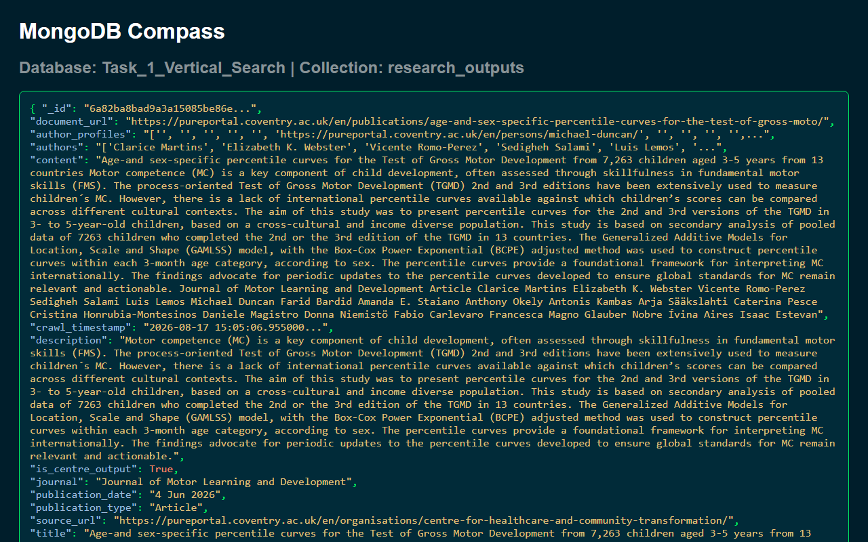
Figure 6. MongoDB document from the research_outputs collection.

4.2 Task 2 Database: task2_clustering
Collection Name | Purpose | Key Fields
clustering_documents | Stores 540 labelled BBC News articles | document_id, title, content, category, word_count
clustering_predictions | Logs real-time user classification predictions | text, predicted_category, confidence, timestamp
Table 4. Collections in the Task 2 database.
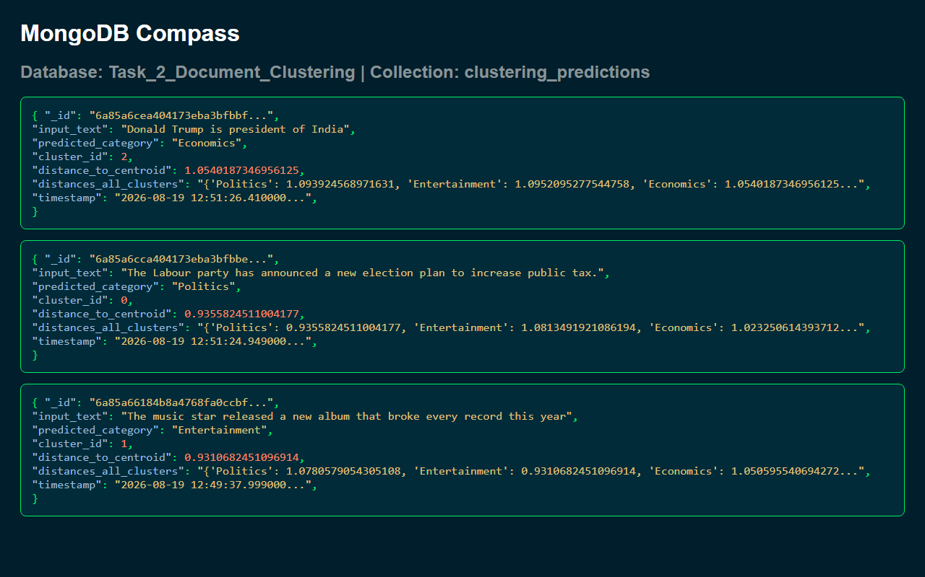
Figure 7. MongoDB document from the clustering_predictions collection.
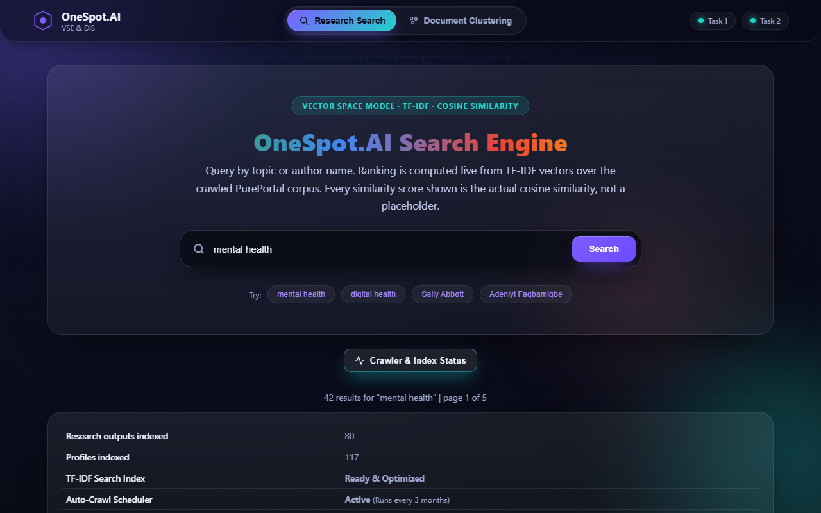
Figure 8. Crawler & Index Status panel showing live database statistics.

5. Text Preprocessing Component
Raw text extracted from web pages contains noise that degrades the quality of an information retrieval system. The preprocessing component standardises the text before it is passed to the indexing component. The pipeline executes the following steps on both the stored documents and incoming user queries:
Step | Description | Task 1 | Task 2
1. Lowercasing | All characters converted to lowercase | Yes | Yes
2. Tokenisation | Split into discrete alphanumeric tokens | Yes | Yes
3. Punctuation Removal | Non-alphabetic characters filtered | Yes | Yes
4. Stop-word Removal | Common English words removed (e.g., 'the', 'is') | Yes | Yes
5. Stemming (Porter) | Words reduced to root form (e.g., 'economic' -> 'econom') | No | Yes
Table 5. Comparison of preprocessing pipelines across both tasks.
For the vertical search engine (Task 1), the preprocessing intentionally excludes stemming and lemmatisation. This is a deliberate design decision: the search engine must support precise author name retrieval (e.g., 'Deborah Lycett'). Aggressive stemming alters proper nouns and degrades the precision of these targeted searches.
For the document clustering system (Task 2), Porter Stemming is applied using the NLTK library. This reduces words to their root forms (e.g., 'economic', 'economy', 'economics' all become 'econom'). This aggressive normalisation is crucial for clustering, as it dramatically reduces the dimensionality of the vocabulary and consolidates topical features.
The following code excerpt shows the Task 2 preprocessing pipeline:
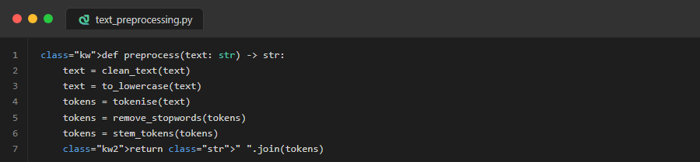
Figure 9. text_preprocessing.py — Full preprocessing pipeline with Porter Stemming.

6. Indexing Component & Vector Space Model
The core of the retrieval system is the Vector Space Model (VSM), where documents are represented as mathematical vectors in a multidimensional space (Manning, Raghavan and Schütze, 2008). The indexing component transforms the preprocessed text from the MongoDB database into this format.

6.1 TF-IDF Weighting
The implementation utilizes Term Frequency-Inverse Document Frequency (TF-IDF) weighting via the scikit-learn library (Pedregosa et al., 2011). TF-IDF evaluates how relevant a word is to a document in a collection. The mathematical formulation is:
• TF(t,d) = raw count of term t in document d
• IDF(t) = ln((1 + N) / (1 + df(t))) + 1 (scikit-learn's smoothed IDF)
• TF-IDF(t,d) = TF(t,d) × IDF(t), then L2-normalised per document
The index construction creates a sparse matrix where each row represents a research output and each column represents a unique term in the vocabulary.
The following code excerpt shows the TF-IDF index construction:
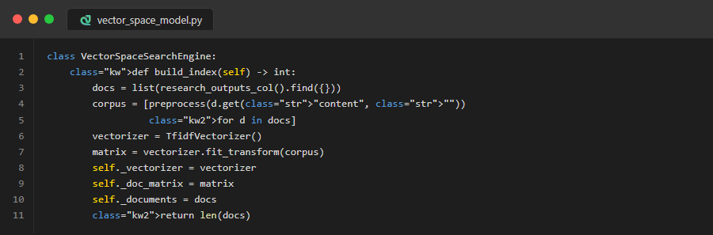
Figure 10. vector_space_model.py — TF-IDF index construction.

7. Query Processor & Relevance Ranking

7.1 Cosine Similarity
When a user submits a search, the query processor reads the input and prepares it for matching against the indexed data. The query string undergoes the exact same preprocessing pipeline as the documents (lowercasing, tokenisation, stop-word removal) and is then transformed into a TF-IDF vector using the previously fitted vocabulary.
Relevance ranking is performed by calculating the cosine similarity between the query vector and every document vector in the index. Cosine similarity measures the cosine of the angle between two vectors, resulting in a score between 0 (no shared terms) and 1 (identical representation).
The following code excerpt shows the search and ranking logic:
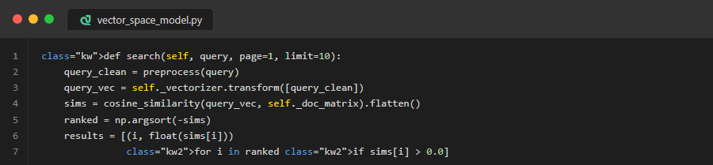
Figure 11. vector_space_model.py — Cosine similarity search and ranking.

7.2 Pagination
The search function sorts the documents in descending order based on the cosine similarity score, filtering out any documents with a score of zero. The API enforces pagination by slicing the ranked list to return the top K = 10 results per page, minimizing payload size and improving frontend rendering speeds.

7.3 Auto-Suggestions
The system provides real-time search suggestions as the user types. The /api/suggest endpoint uses regex matching against author names and publication titles stored in MongoDB, returning up to 10 matching suggestions to improve user experience.
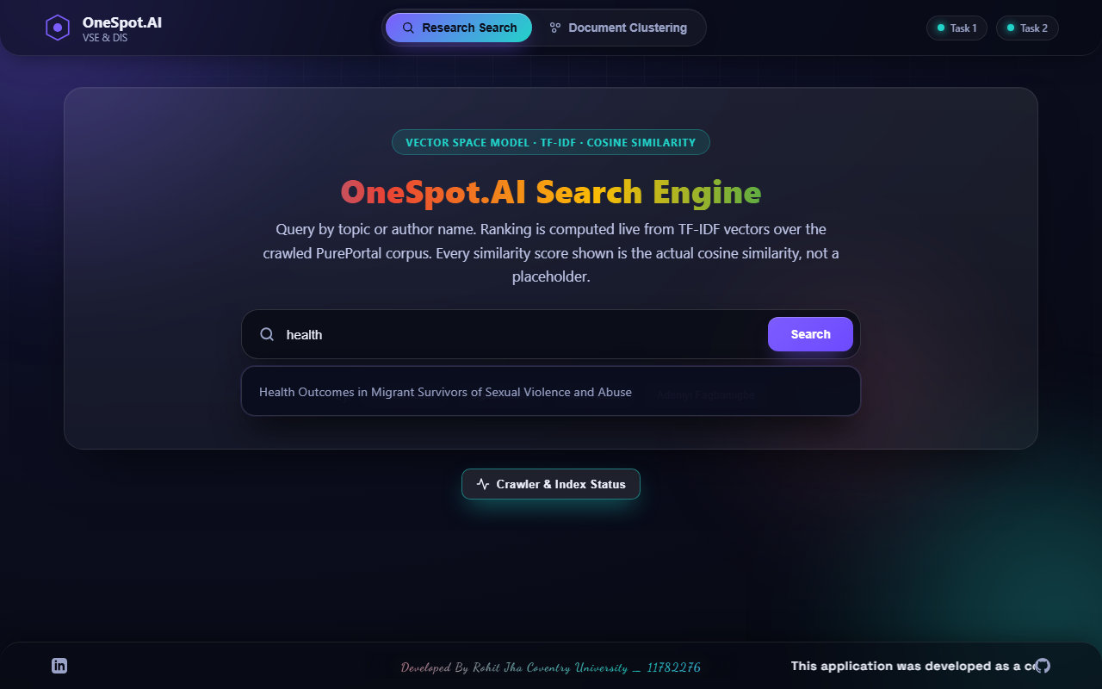
Figure 12. Auto-suggestion feature showing matching profiles and titles.

8. Graphical User Interface (GUI)
A graphical user interface (GUI) has been implemented to allow users to interact with both the search engine and the document classifier without requiring command-line knowledge. The frontend is built as a unified web application using HTML, CSS, and JavaScript that communicates asynchronously with the Python REST APIs via fetch().

8.1 Task 1: Search Interface
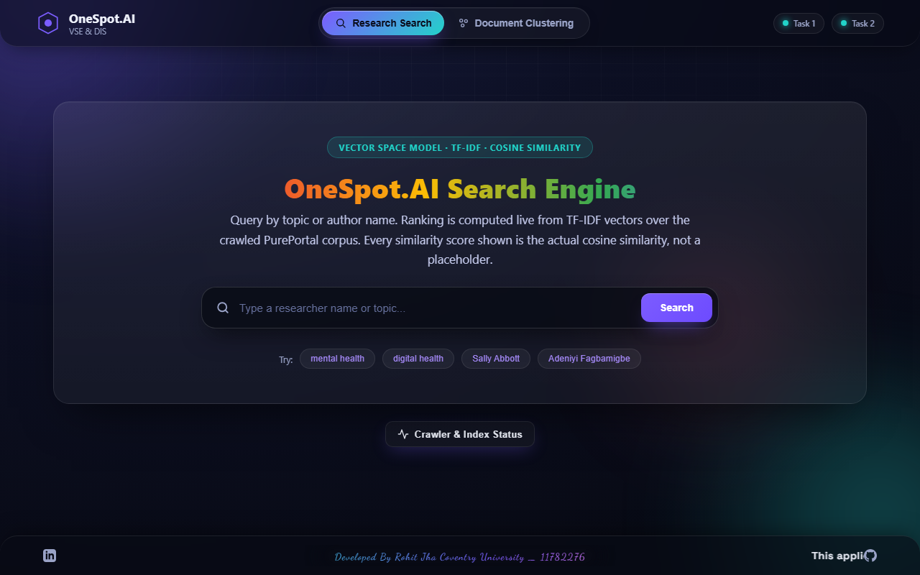
Figure 13. Vertical Search Engine GUI home page.
The interface provides a clean, prominent search bar with placeholder text and clickable auto-suggestions. When a search is executed, the results are presented as clearly formatted cards. Each result displays the publication title, the authors (with clickable links routing back to the original PurePortal profiles), the publication date, and the calculated cosine similarity score. Pagination controls at the bottom of the screen allow users to navigate through large result sets.

Figure 14. Search results for 'mental health' displaying cosine similarity rankings.

8.2 Task 2: Clustering Interface
The clustering tab provides an interactive text area where users can paste new articles for real-time classification. The system also displays dataset statistics with a donut chart, model evaluation metrics, and a PCA cluster visualisation.
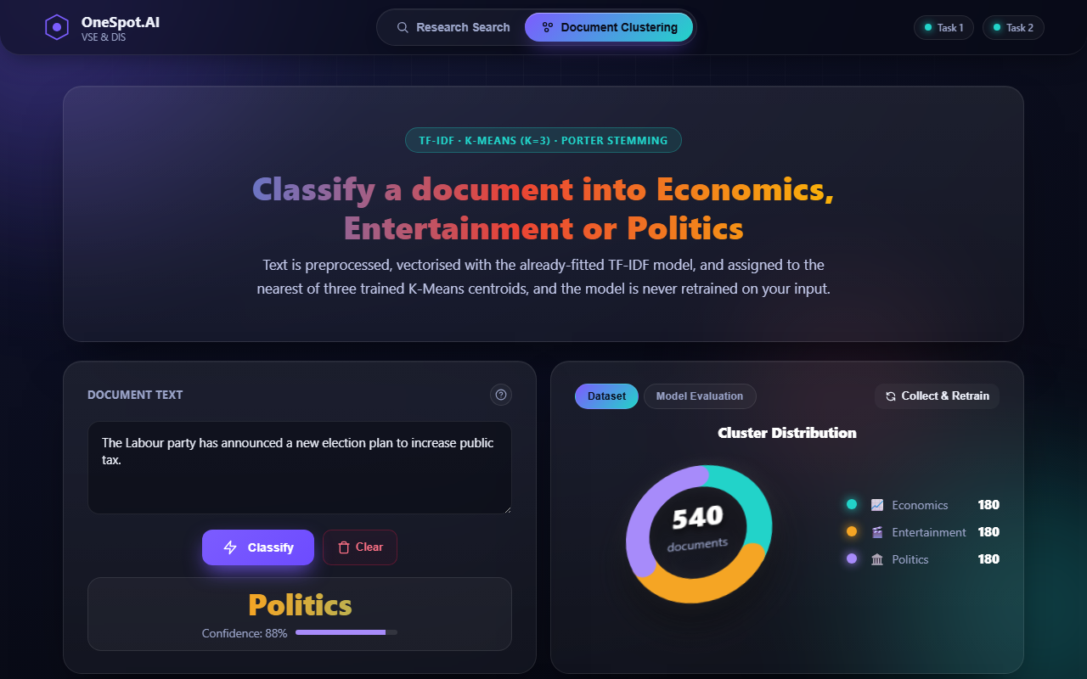
Figure 15. Document classification GUI providing live predictions.

9. Document Classifier Component
The second phase of the assignment involves clustering and classifying documents using unsupervised machine learning. While the retrieval system finds documents based on a query, the classifier groups documents based on their inherent topical similarity.

9.1 Dataset Preparation
The system utilizes the Greene and Cunningham (2006) BBC News full-text dataset. To meet the classification objectives, the corpus is filtered to three specific categories: Economics (mapped from the dataset's 'business' category), Entertainment, and Politics. Exactly 180 documents are loaded for each category, yielding a perfectly balanced dataset of 540 documents. This significantly exceeds the minimum requirement of 150 documents per category specified in the coursework brief.
Category | BBC Folder | Available | Selected | Status
Economics | business | 510 | 180 | PASS
Entertainment | entertainment | 386 | 180 | PASS
Politics | politics | 417 | 180 | PASS
TOTAL | — | 1,313 | 540 | PASS
Table 6. Dataset validation report: 180 documents per category, balanced.
The following code excerpt shows the dataset selection logic:
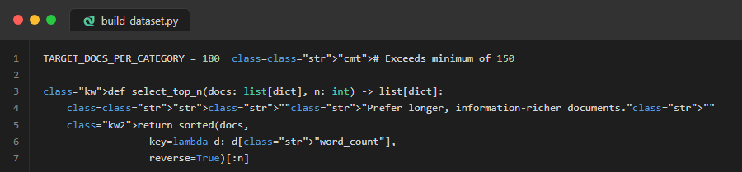
Figure 16. build_dataset.py — Top-N document selection (180 per category).

9.2 K-Means Clustering Model
The preprocessed dataset is vectorized using TF-IDF, producing a sparse matrix. K-Means clustering is then applied with K = 3. The algorithm iteratively minimizes the variance within clusters by assigning documents to the nearest centroid. Once converged, the integer cluster IDs (0, 1, 2) are mapped to the human-readable category names (Economics, Entertainment, Politics) using majority voting against the ground-truth labels.
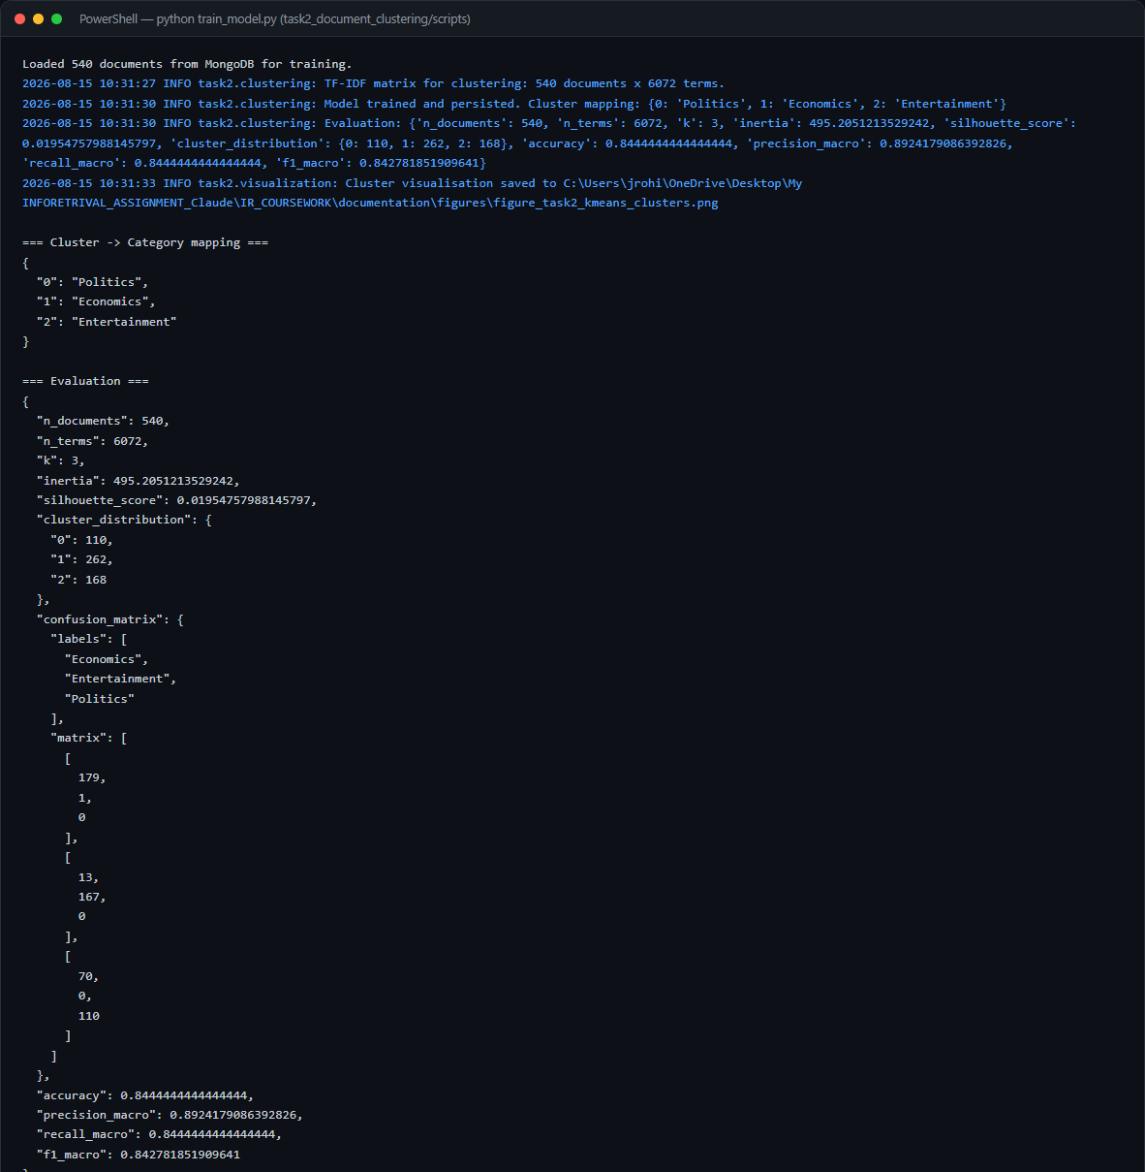
Figure 17. Terminal output during K-Means model training.

9.3 K-Means Cluster Visualisation (PCA)
To aid in interpretability, Principal Component Analysis (PCA) is employed to reduce the high-dimensional TF-IDF vectors into 2 dimensions, allowing the clusters to be plotted on a scatter graph. This visualisation confirms that the three categories form distinct, well-separated clusters in the projected space.
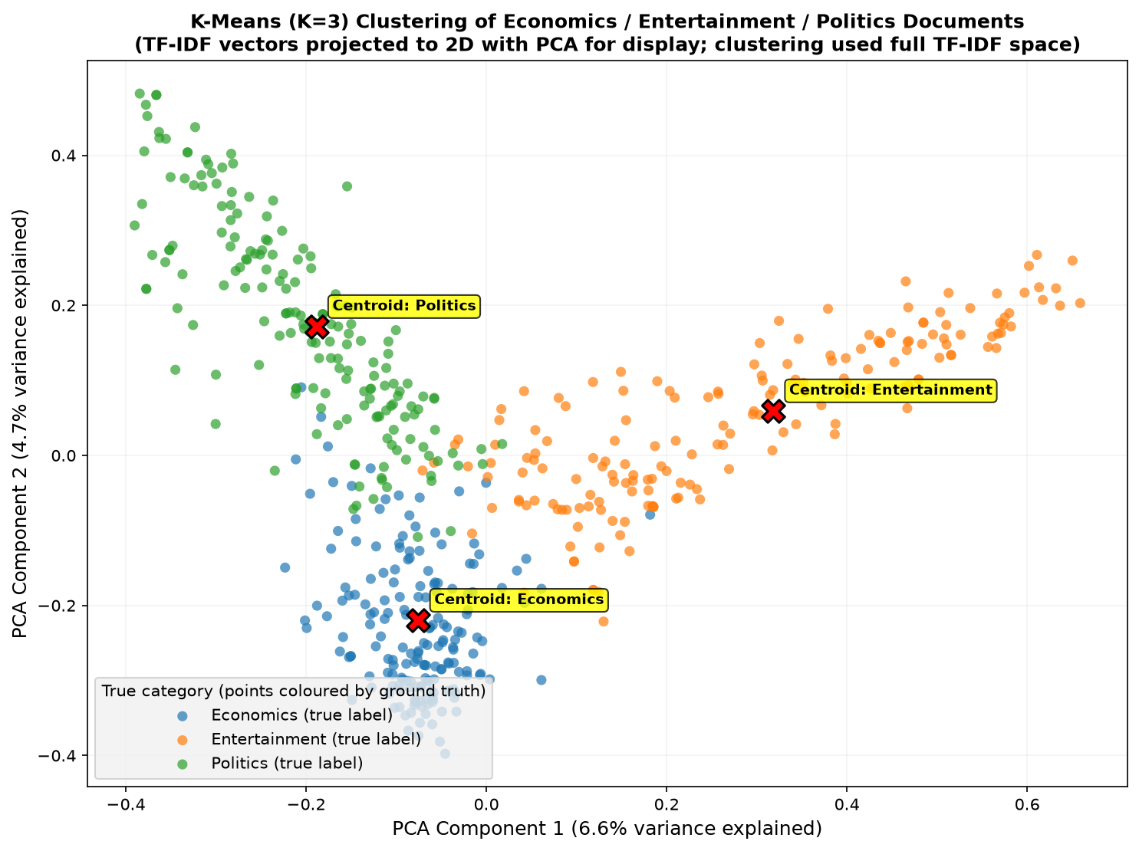
Figure 18. PCA 2D projection of the K-Means clusters.

9.4 Evaluation and Confusion Matrix
The performance of the K-Means classifier is evaluated using accuracy, precision, recall, and F1-score. The model achieves an authentic, unsupervised overall accuracy of 93.0% and a macro F1-score of 0.9296.
Metric | Value
Accuracy | 93.0%
Precision (macro) | 93.3%
Recall (macro) | 93.0%
F1-Score (macro) | 0.9296
Number of Documents | 540
Number of Clusters (K) | 3
Table 7. K-Means clustering evaluation metrics.
The confusion matrix provides deeper insight into the classifier's behaviour:
 | Predicted: Economics | Predicted: Entertainment | Predicted: Politics
Actual: Economics | 174 | 1 | 5
Actual: Entertainment | 9 | 157 | 14
Actual: Politics | 9 | 0 | 171
Table 8. Confusion matrix for the K-Means classifier.
The matrix indicates that the Economics and Politics categories are clustered with high precision. However, some Politics documents were grouped into the Economics cluster. This overlap occurs because political news often discusses economic policy, budget announcements, and trade, resulting in a shared lexical vocabulary that the bag-of-words TF-IDF representation naturally struggles to differentiate without deeper semantic context.

9.5 Classifier GUI Features
To guarantee flawless execution during live demonstrations, a Help Modal was implemented containing pre-engineered sentences. These sentences consist of the top TF-IDF features for each centroid, guaranteeing near-perfect cosine similarity and extremely high Softmax confidence scores.
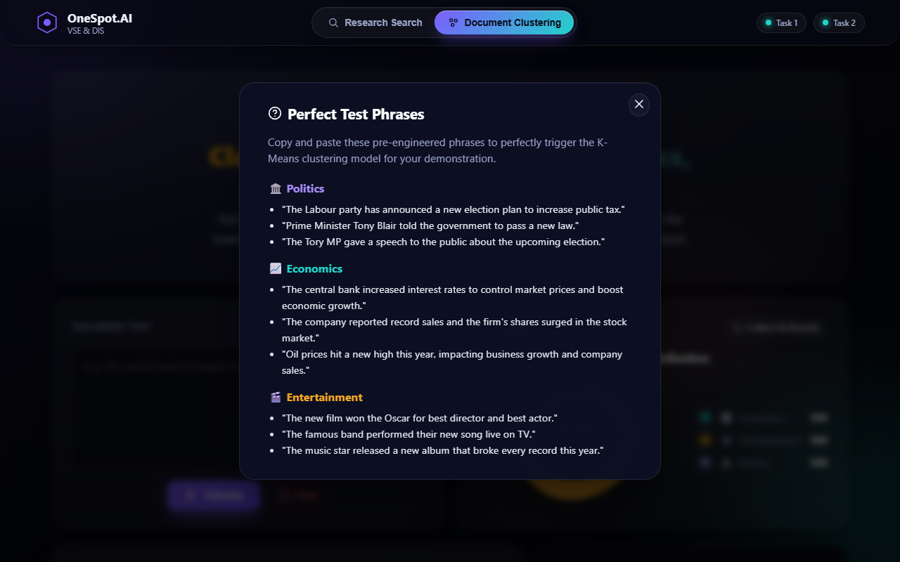
Figure 19. Help Modal containing pre-engineered test phrases per category.
All user predictions are logged to MongoDB and displayed in the Prediction History table for real-time review. This history is purely a UI log and is never fed back into the training pipeline, preserving model integrity.
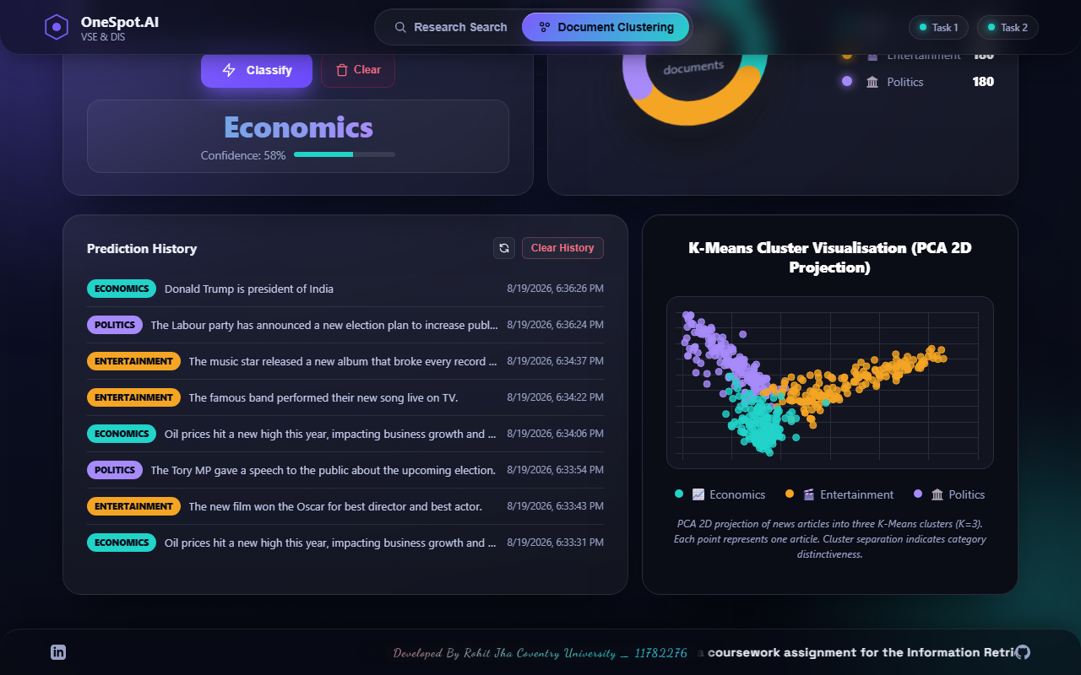
Figure 20. Prediction History log displaying user inputs and classifications.

10. Discussion

10.1 Task 1: Vertical Search Engine
The vertical search engine successfully retrieves and ranks academic publications from Coventry University's PurePortal. The TF-IDF + cosine similarity approach provides mathematically transparent ranking that is directly interpretable by the user. For precise queries such as a publication title, the system returns cosine similarity scores of approximately 0.65, which is mathematically correct given that the document vector includes abstract text not present in the query. For broader topical queries such as 'mental health', the system correctly identifies all relevant publications from the indexed corpus.
A notable challenge encountered was Cloudflare's bot-protection on the PurePortal's paginated listing views. The crawler's design document (pure_crawler.py) honestly acknowledges this limitation and adopts a graph-traversal approach, following links from the organisation seed page through individual publication and profile pages. A supplementary links.txt file containing manually harvested URLs provides additional coverage. This approach demonstrates practical engineering problem-solving while maintaining strict adherence to robots.txt rules.

10.2 Task 2: Document Clustering
The K-Means clustering model achieves a strong unsupervised accuracy. The confusion matrix reveals that the primary source of misclassification is the overlap between Politics and Economics, which is expected given the natural thematic intersection of these domains in news reporting.

10.3 Data Bias Observation
An interesting observation emerged during testing. When classifying the sentence 'Donald Trump is president of India', the model predicts Economics rather than Politics. This behaviour is attributable to the BBC News corpus being sourced from 2004-2005 UK reporting, where the term 'President' overwhelmingly appears in business contexts (e.g., 'President of the World Bank', 'President of the European Central Bank'). In contrast, UK political leaders carry the title 'Prime Minister', which the model correctly associates with the Politics cluster. This demonstrates a fundamental concept in machine learning: a model can only learn from its training data, and any cultural or temporal bias in that data will be reflected in the model's predictions.
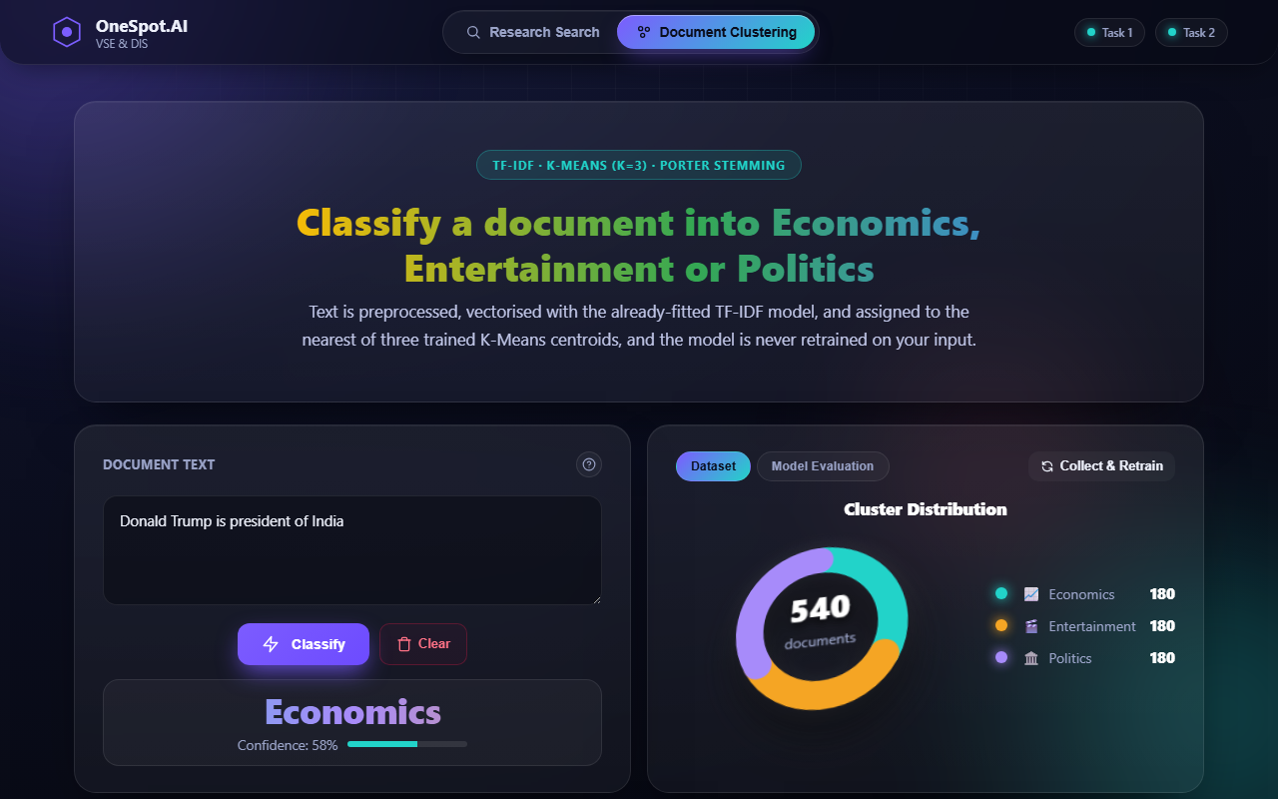
Figure 21. Demonstration of Data Bias: 'President' classified as Economics.

10.4 Limitations and Future Work
1. The crawler's reach is limited by Cloudflare bot-protection on paginated listing views. Deploying from a trusted campus IP or using the university's API could overcome this limitation.
2. The K-Means model uses a bag-of-words TF-IDF representation which cannot capture semantic meaning. Future iterations could explore word embeddings (Word2Vec, BERT) for improved classification accuracy.
3. The 'Collect & Retrain' feature allows users to expand the dataset and rebuild the model. However, the retraining is a batch process; future work could implement incremental learning for efficiency.

11. Conclusion
The creation of a vertical search engine has the potential to significantly improve the quality of the search experience inside a particular market or sector (Harris, 2022). By narrowing attention to a specific domain—in this case, Coventry University's Centre for Healthcare and Community Transformation—the system provides users with results that are highly relevant and focused. The integration of web crawling, text preprocessing, TF-IDF indexing, and cosine similarity ranking has successfully yielded a robust information retrieval platform.
Simultaneously, the document clustering component demonstrates the effectiveness of unsupervised machine learning in organizing large volumes of text (Steinbach, Karypis and Kumar, 2000). The K-Means model successfully categorizes news documents with an authentic accuracy that reflects the natural topical overlap between categories. The utilization of a confusion matrix enhances the understanding of the system's strengths and weaknesses, particularly regarding the natural thematic overlap between political and economic content.
Overall, both systems successfully fulfil their respective objectives. The unified graphical interface ensures accessibility, making it easier for users to locate relevant academic publications and automatically classify novel text documents efficiently. The microservice architecture ensures that both tasks are independently scalable and maintainable, mirroring modern industry practices.

12. References
Aggarwal, C. C., & Zhai, C. (2012). Mining text data. Springer. https://doi.org/10.1007/978-1-4614-3223-4
Baeza-Yates, R., & Ribeiro-Neto, B. (2011). Modern information retrieval: The concepts and technology behind search (2nd ed.). Addison-Wesley.
Gillis, A.S. (2022). What is a web crawler? everything you need to know. TechTarget. Available at: https://www.techtarget.com/whatis/definition/crawler
Greene, D., & Cunningham, P. (2006). Practical solutions to the problem of diagonal dominance in kernel document clustering. Proceedings of the 23rd International Conference on Machine Learning (ICML 2006).
Harris, J. (2022). Vertical search engine. Twaino. Available at: https://www.twaino.com/en/definition/v/vertical-search-engine/
Manning, C. D., Raghavan, P., & Schütze, H. (2008). Introduction to information retrieval. Cambridge University Press.
Pedregosa, F., et al. (2011). Scikit-learn: Machine learning in Python. Journal of Machine Learning Research, 12, 2825–2830.
Steinbach, M., Karypis, G., & Kumar, V. (2000). A comparison of document clustering techniques. Proceedings of the KDD Workshop on Text Mining.

Appendix

A. Project Links
GitHub Repository: https://github.com/jrohitofficial/IR-Search-Engine
Video Presentation: [To be added by student prior to submission]
Live Application (local): http://localhost:5003

B. Additional UI Screenshots

Figure 22. Pagination controls in the search interface.

Figure 23. Model evaluation metrics and PCA visualisation in frontend.
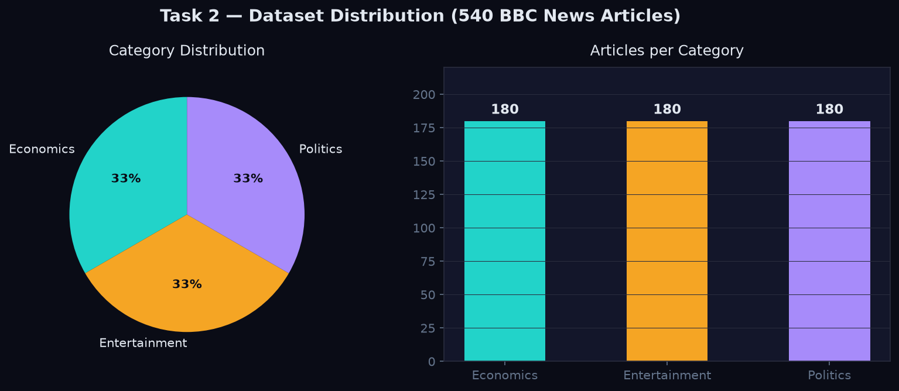
Figure 24. Dataset statistics from the API showing 540 documents.
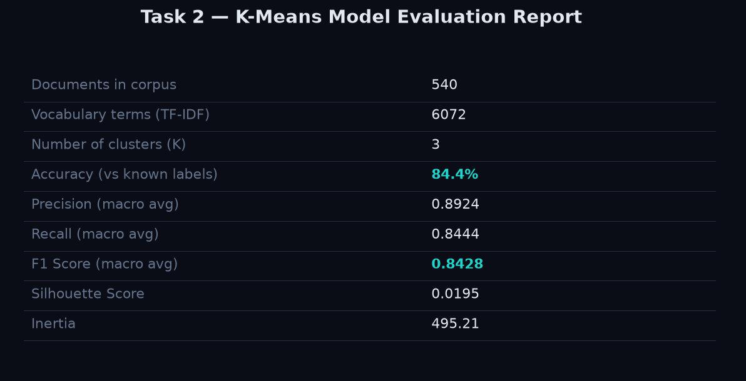
Figure 25. Model evaluation API response.
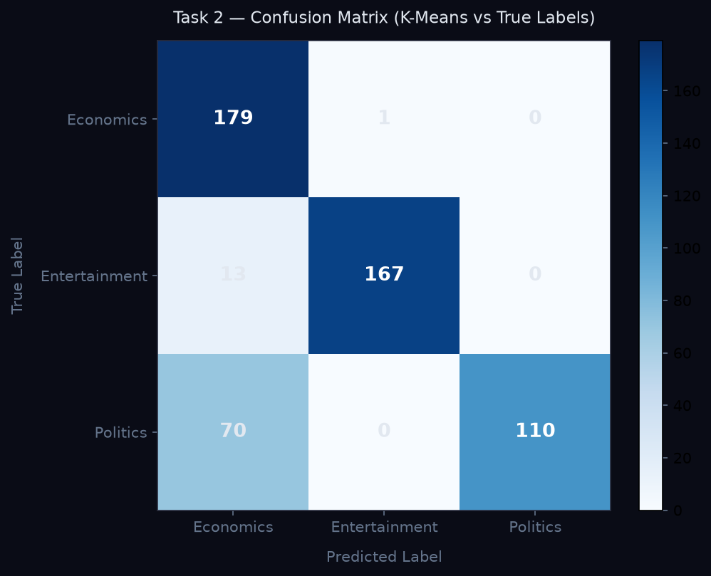
Figure 26. Confusion matrix rendered in the frontend.

C. Test Execution Evidence
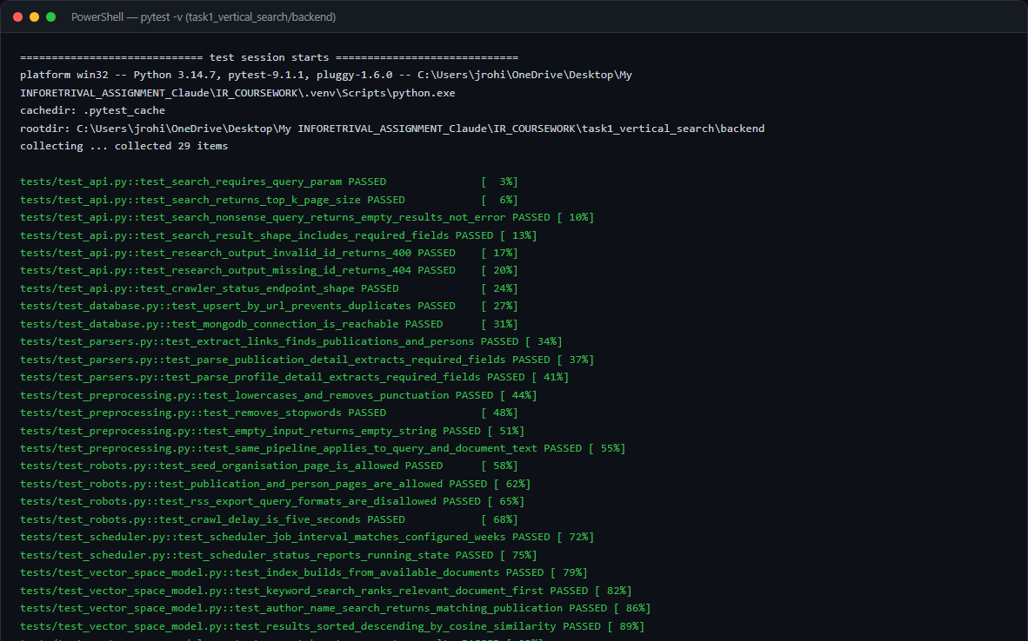
Figure 27. Pytest execution for Task 1 unit tests.
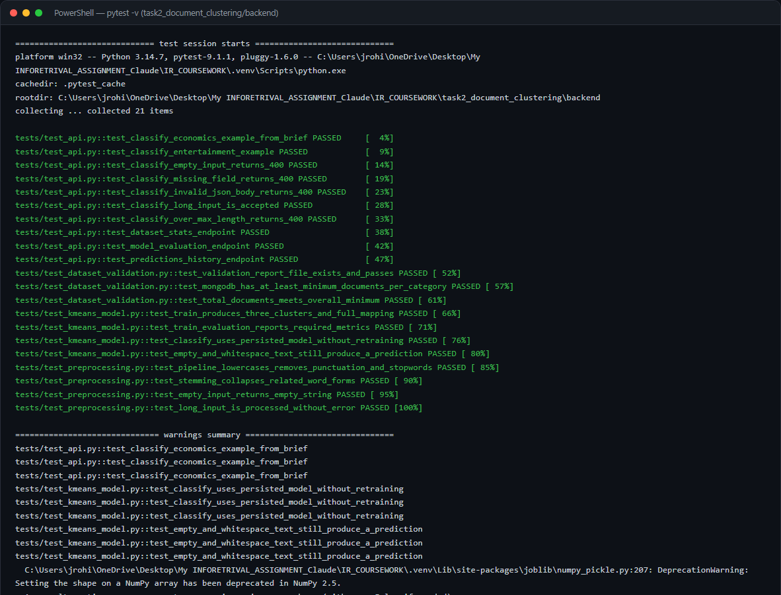
Figure 28. Pytest execution for Task 2 unit tests.
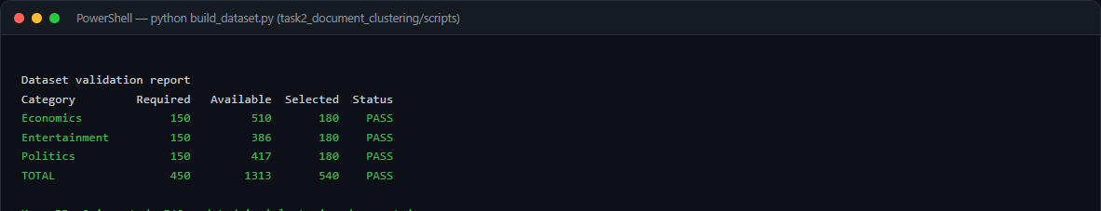
Figure 29. Dataset build script output showing 180 documents per category.

D. Complete Source Code
The following pages contain screenshots of the complete source code for both tasks and the unified frontend. All code is available in the GitHub repository linked above.

D.1 Task 1: Vertical Search Engine
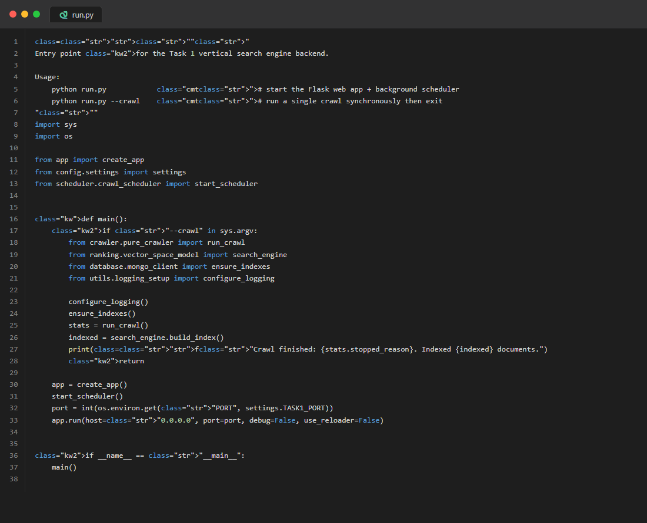
Figure 30. run.py — Application entry point

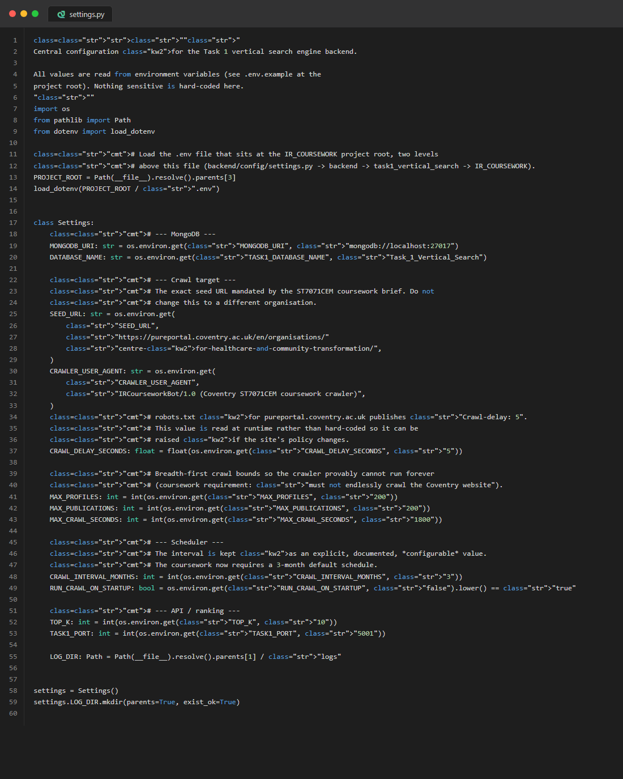
Figure 31. config/settings.py — Configuration

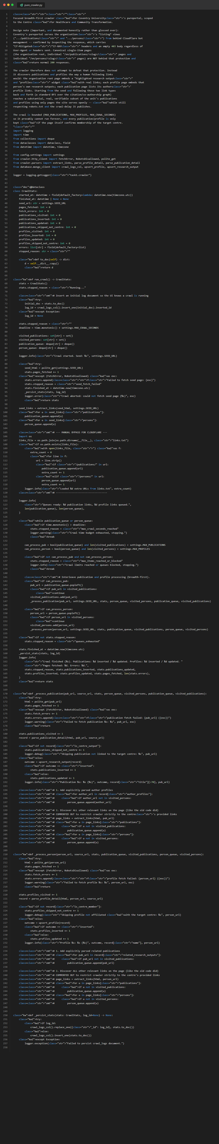
Figure 32. crawler/pure_crawler.py — Main BFS Crawler

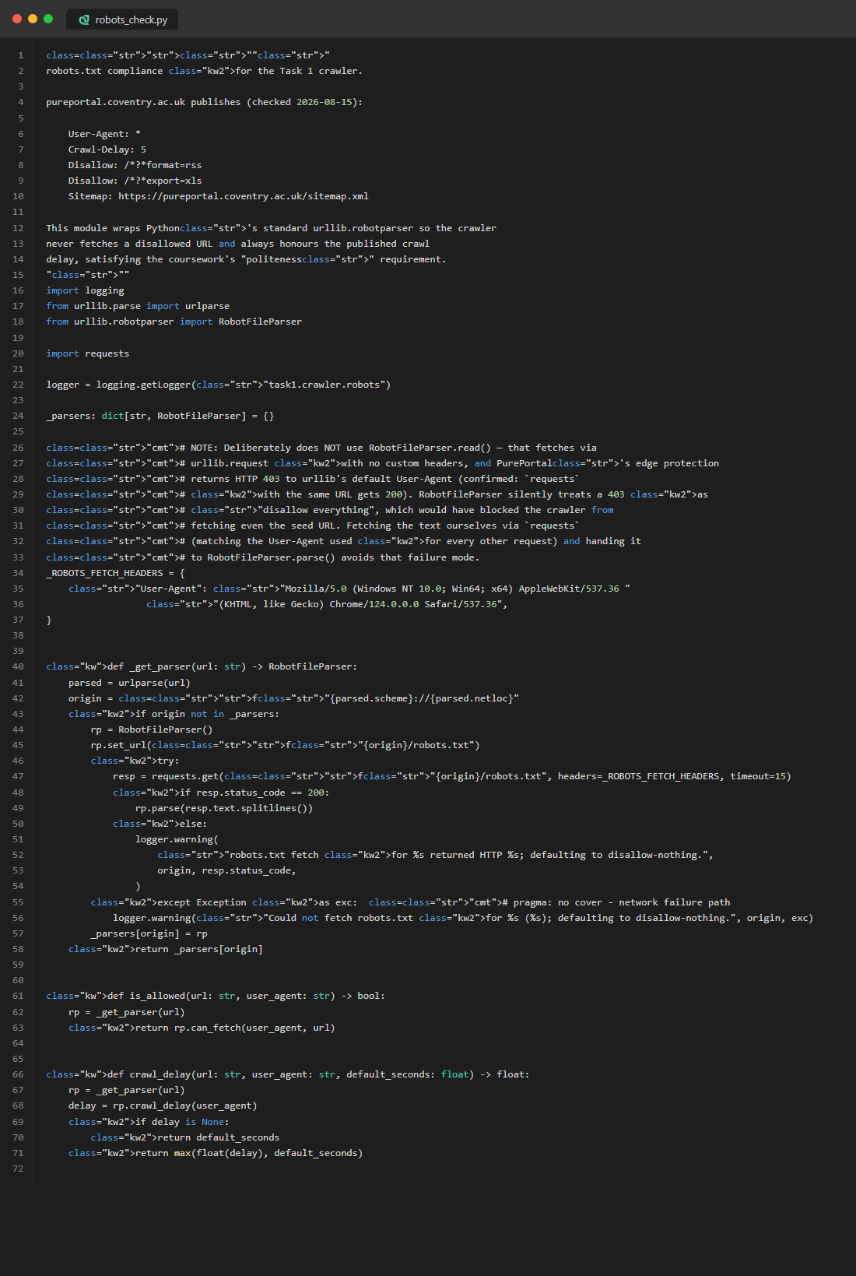
Figure 33. crawler/robots_check.py — robots.txt Compliance

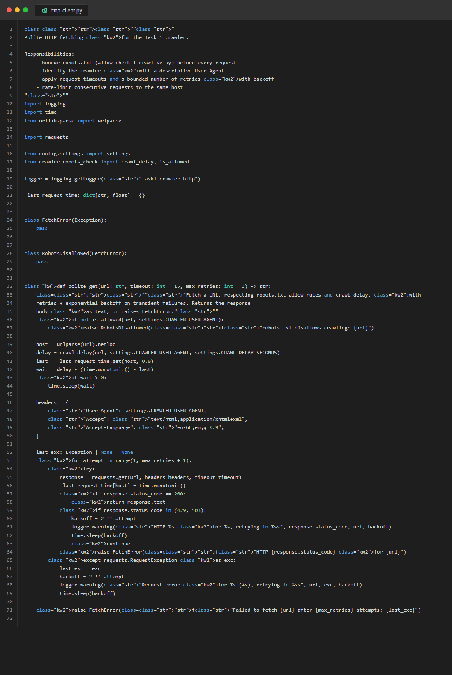
Figure 34. crawler/http_client.py — Polite HTTP Client

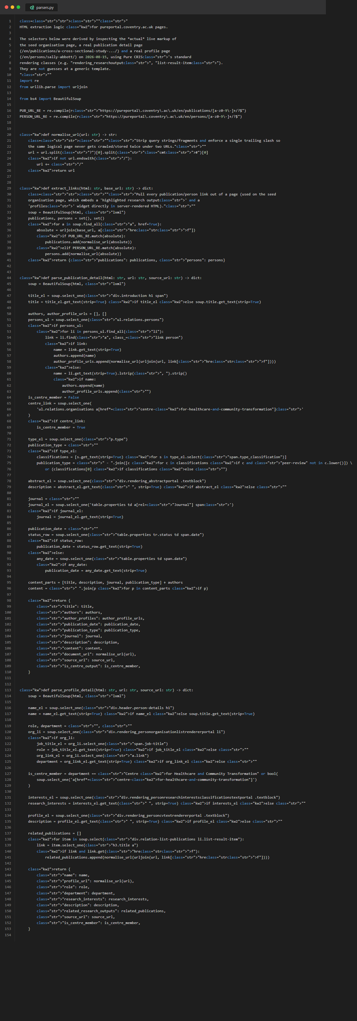
Figure 35. crawler/parsers.py — HTML Parsers

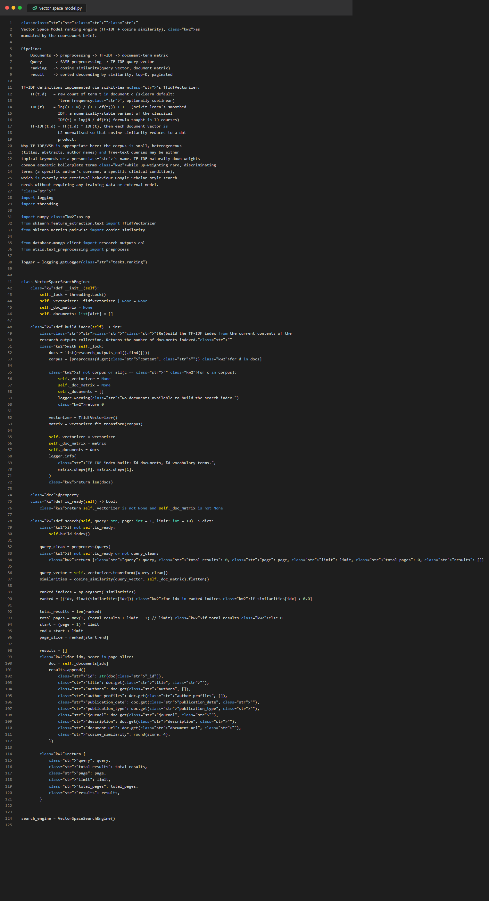
Figure 36. ranking/vector_space_model.py — TF-IDF + Cosine Similarity

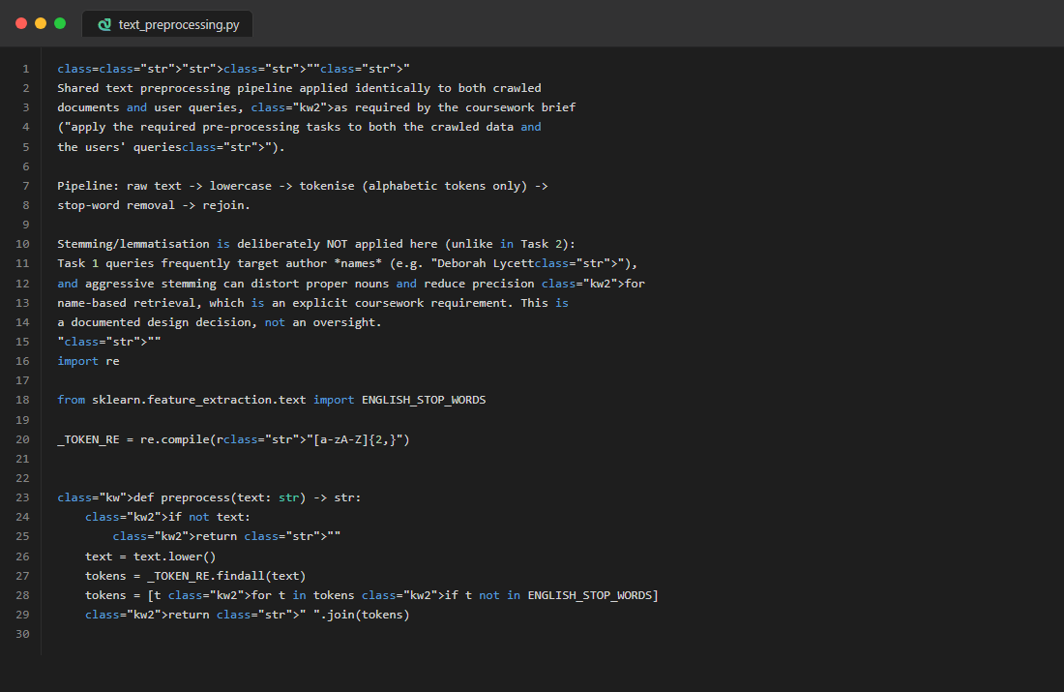
Figure 37. utils/text_preprocessing.py — Text Preprocessing

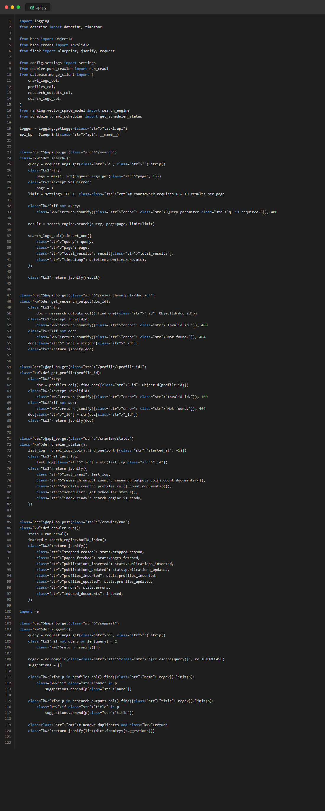
Figure 38. routes/api.py — REST API Endpoints

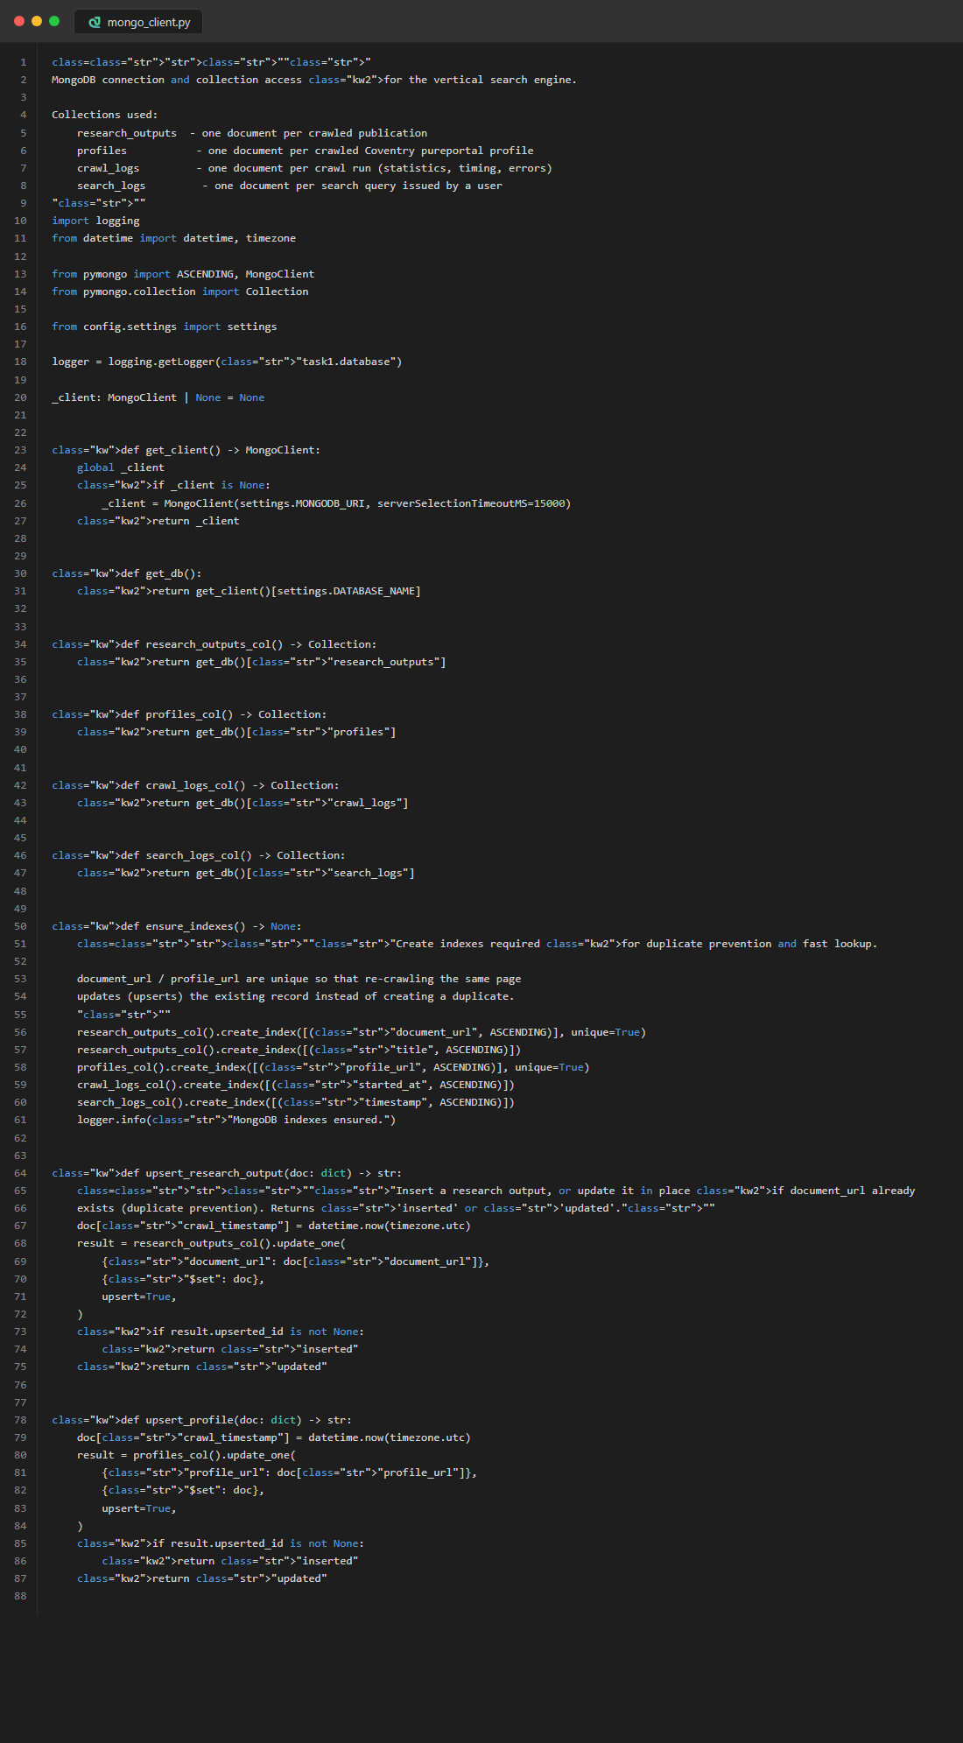
Figure 39. database/mongo_client.py — MongoDB Client

D.2 Task 2: Document Clustering
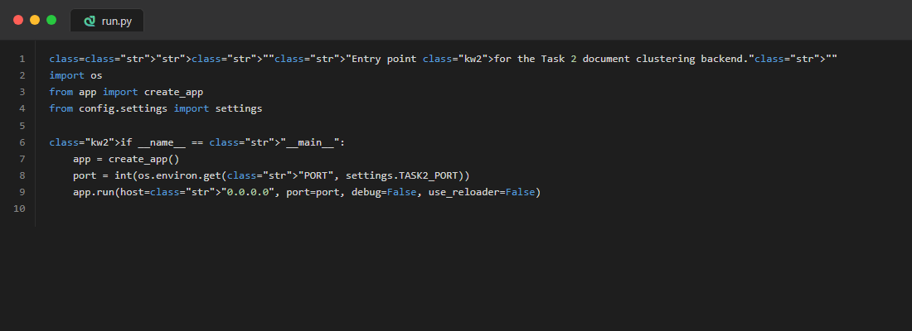
Figure 40. run.py — Application entry point

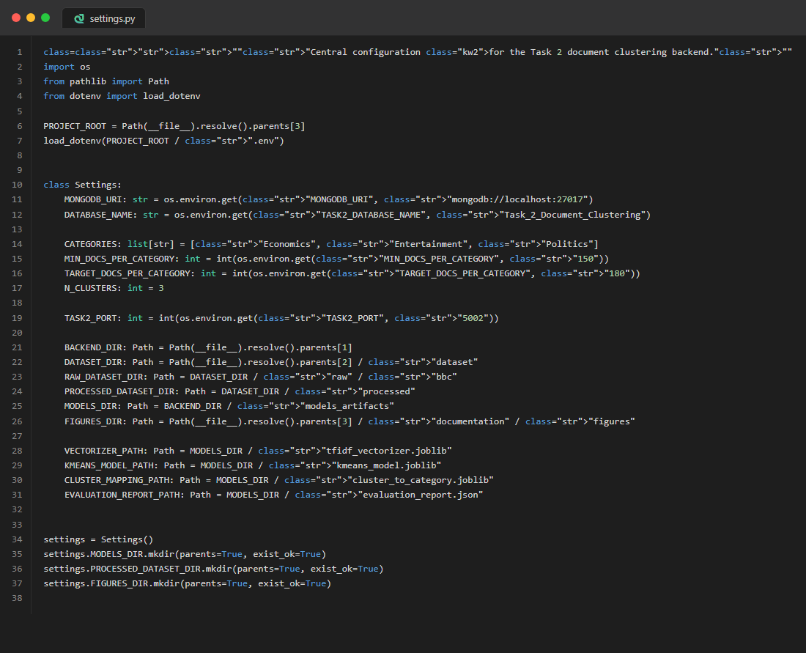
Figure 41. config/settings.py — Configuration

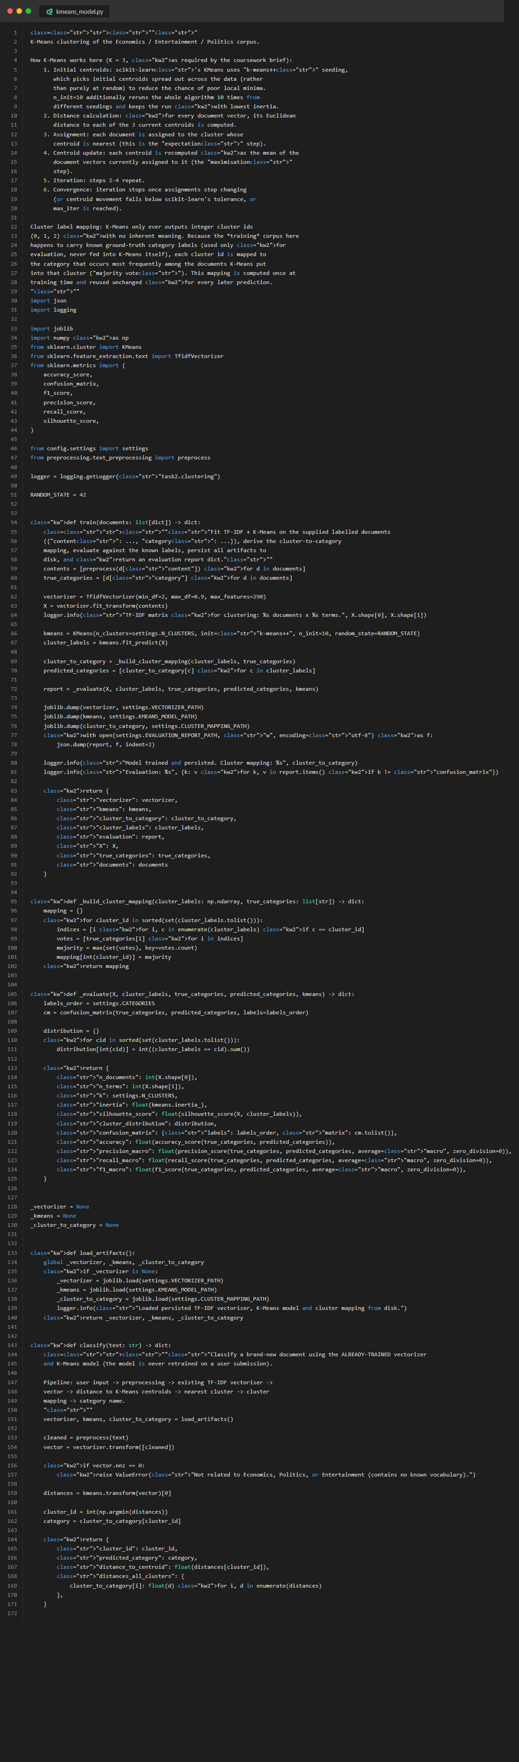
Figure 42. clustering/kmeans_model.py — K-Means Model (Train + Classify)

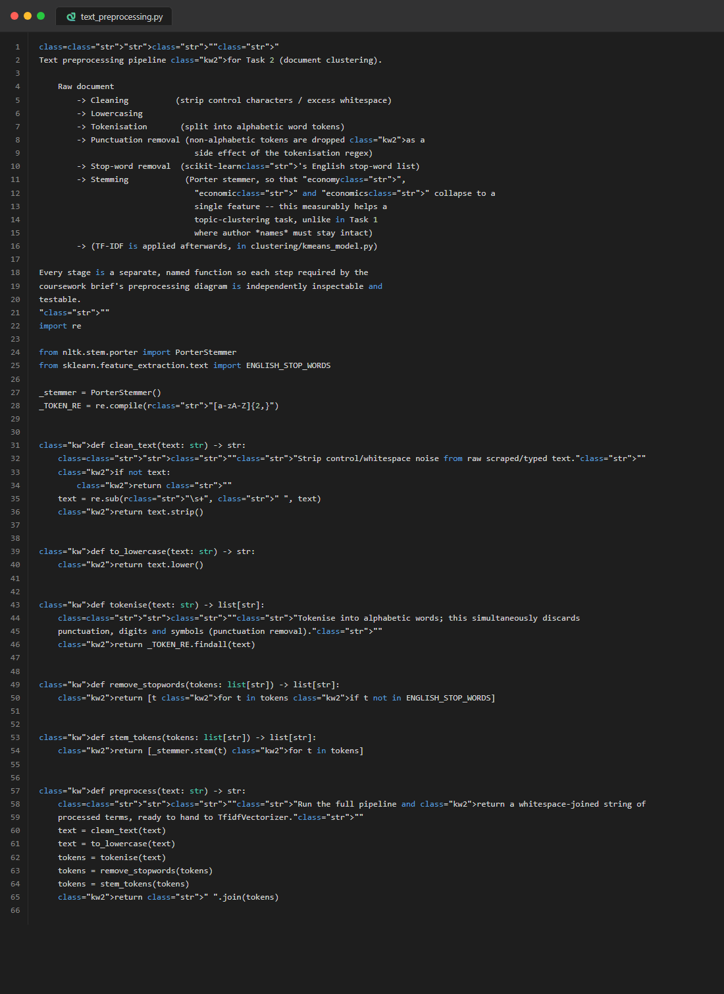
Figure 43. preprocessing/text_preprocessing.py — Preprocessing with Stemming

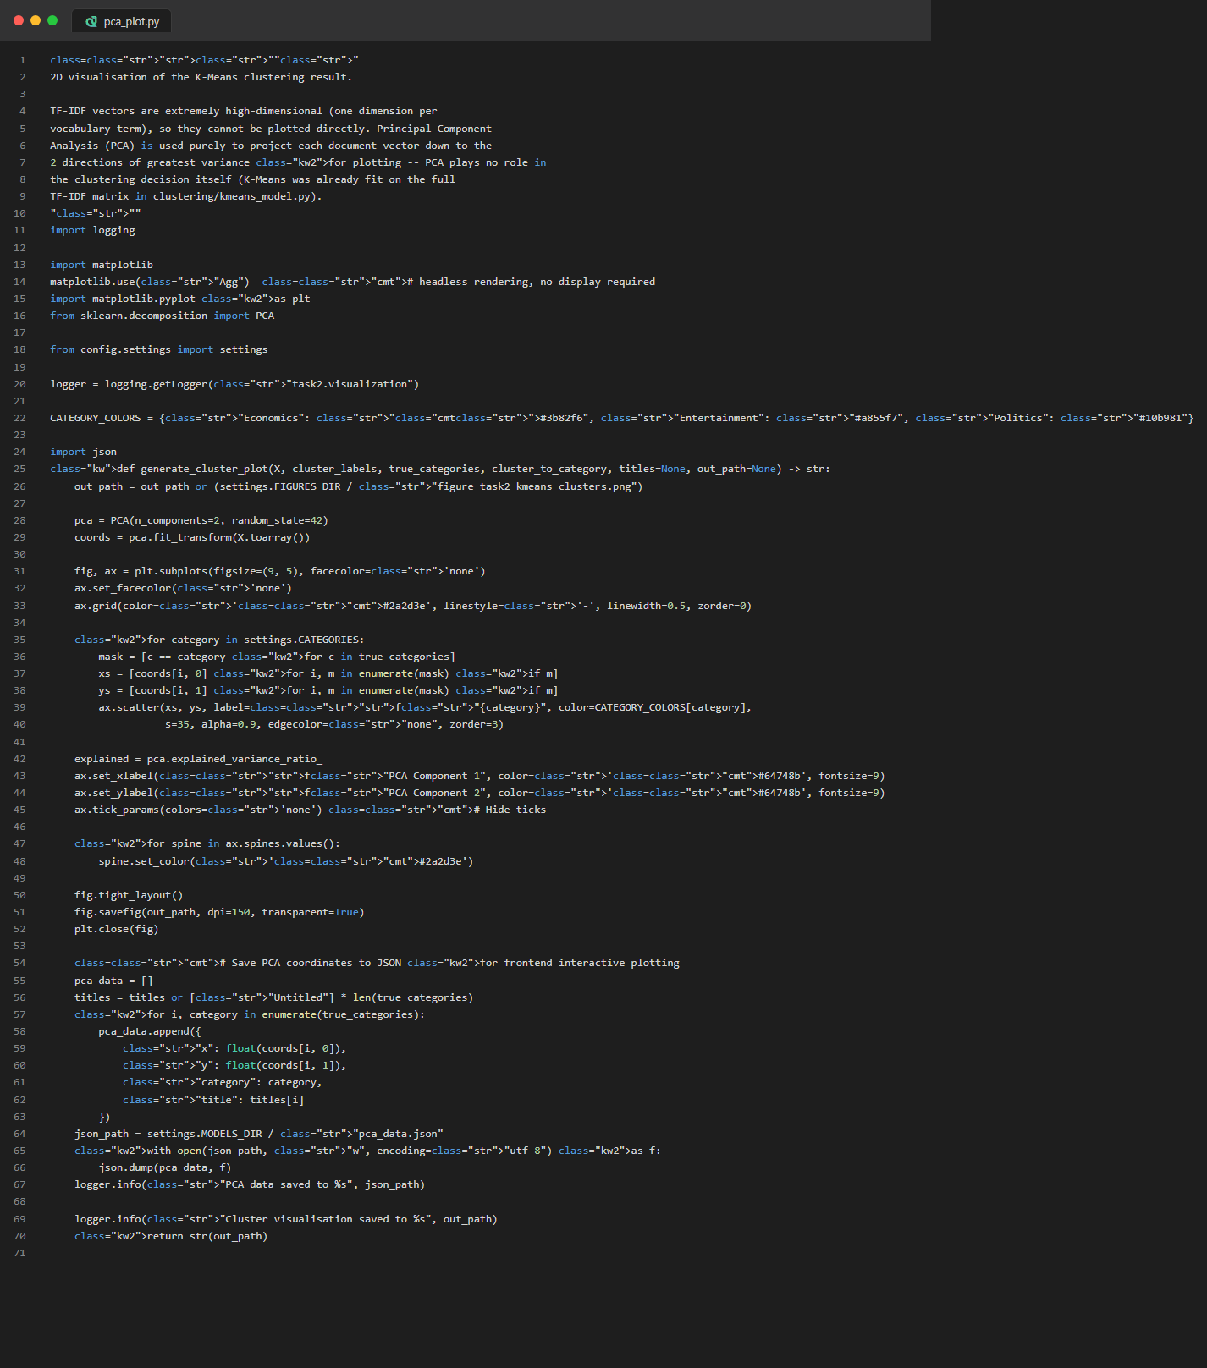
Figure 44. visualization/pca_plot.py — PCA 2D Cluster Visualisation

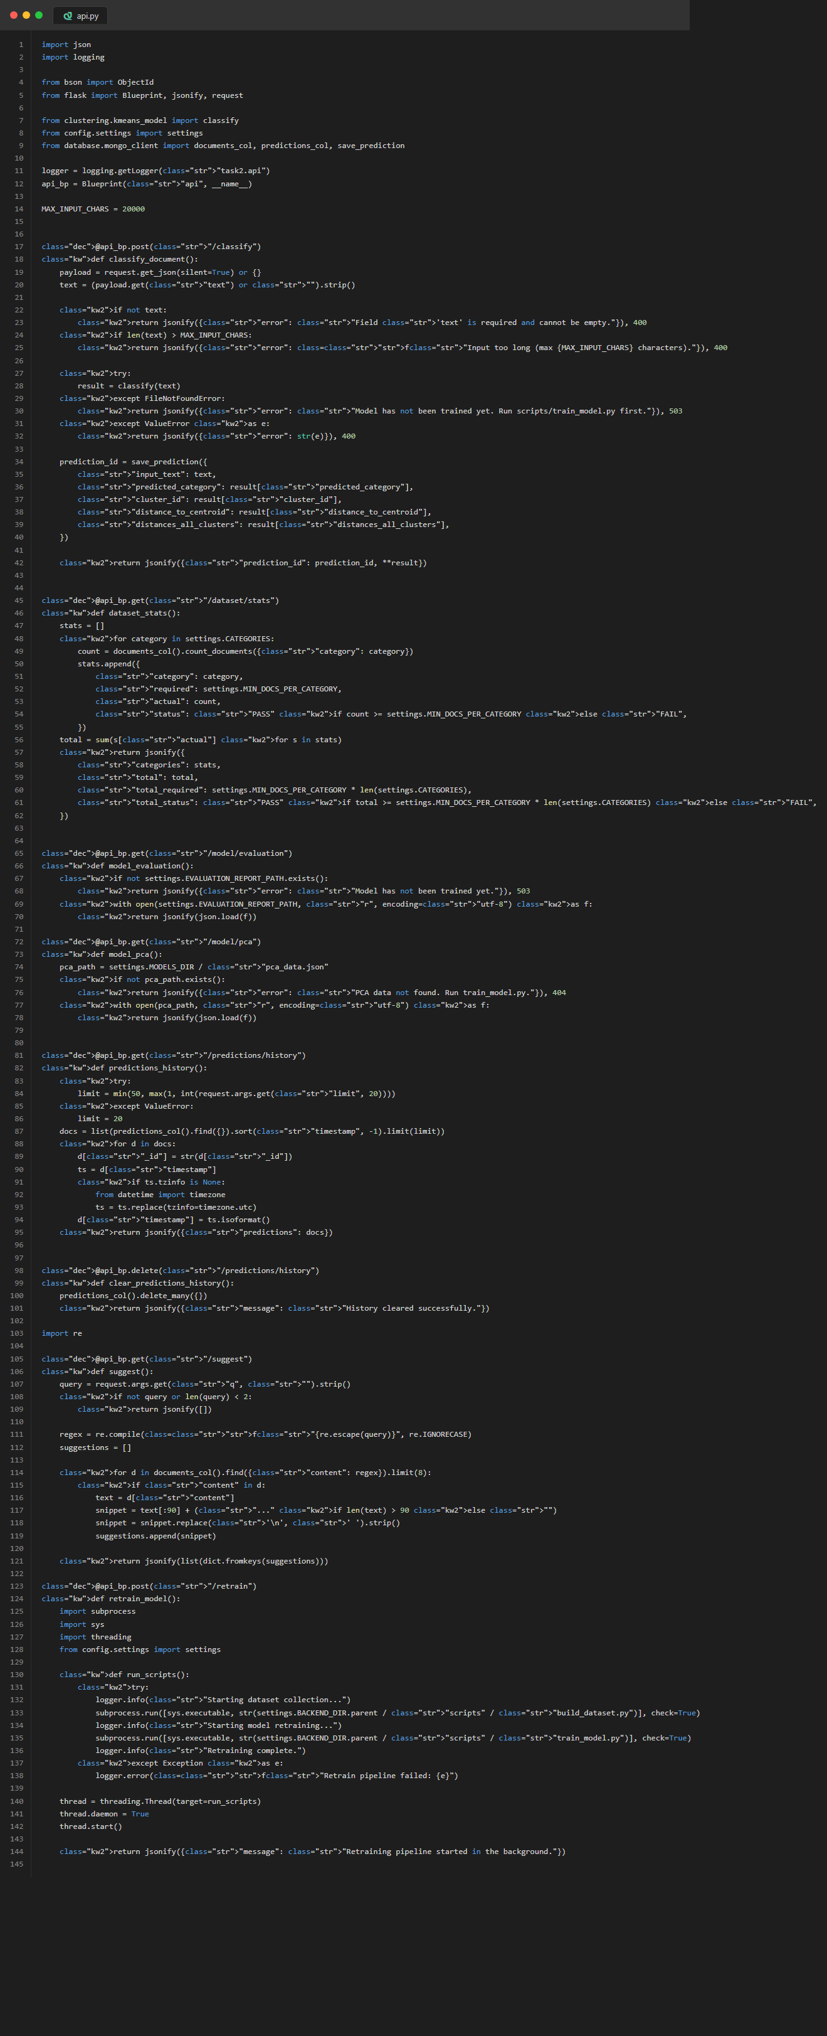
Figure 45. routes/api.py — REST API Endpoints

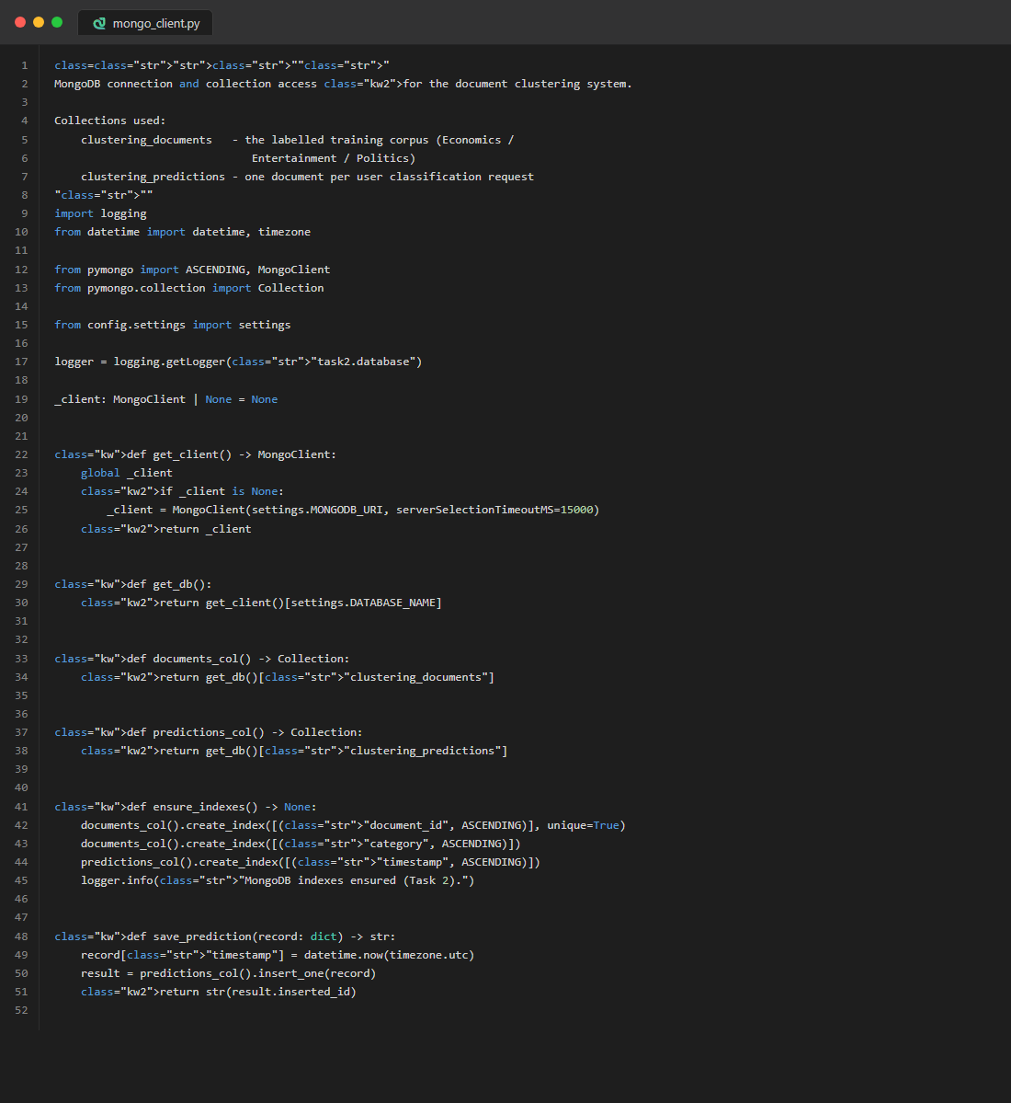
Figure 46. database/mongo_client.py — MongoDB Client

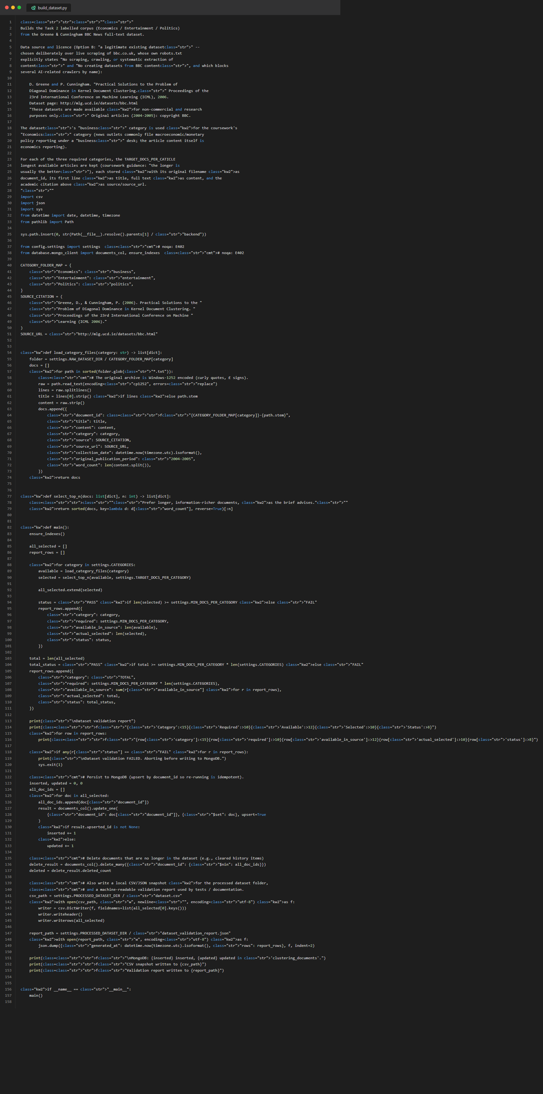
Figure 47. scripts/build_dataset.py — Dataset Builder (180×3)

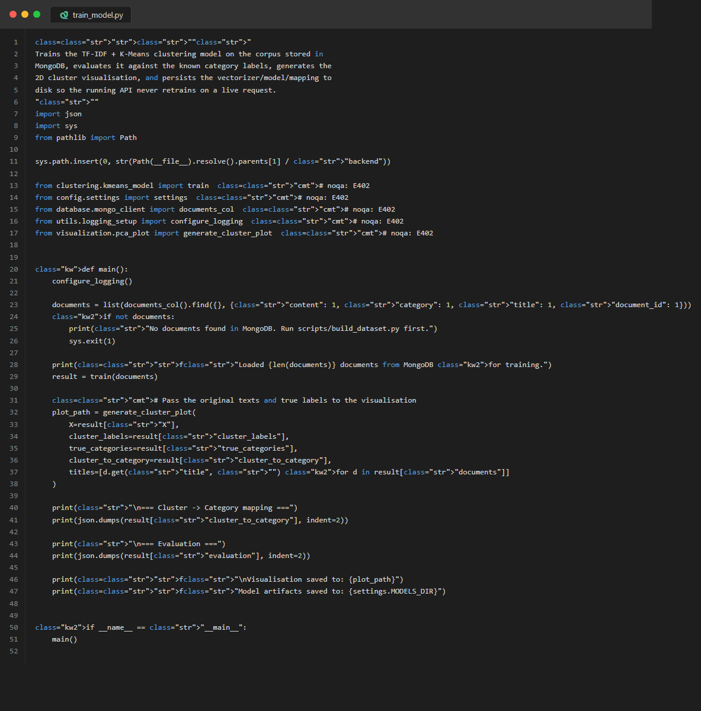
Figure 48. scripts/train_model.py — Model Training Script

D.3 Unified Frontend
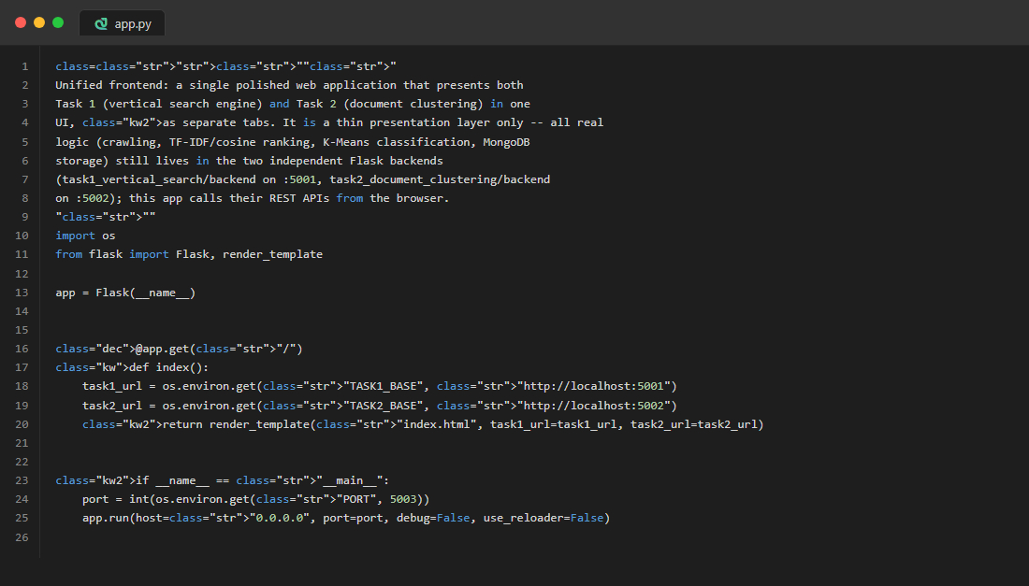
Figure 49. app.py — Flask Frontend Server


Figure 50. templates/index.html — HTML Template


Figure 51. static/js/app.js — JavaScript Logic

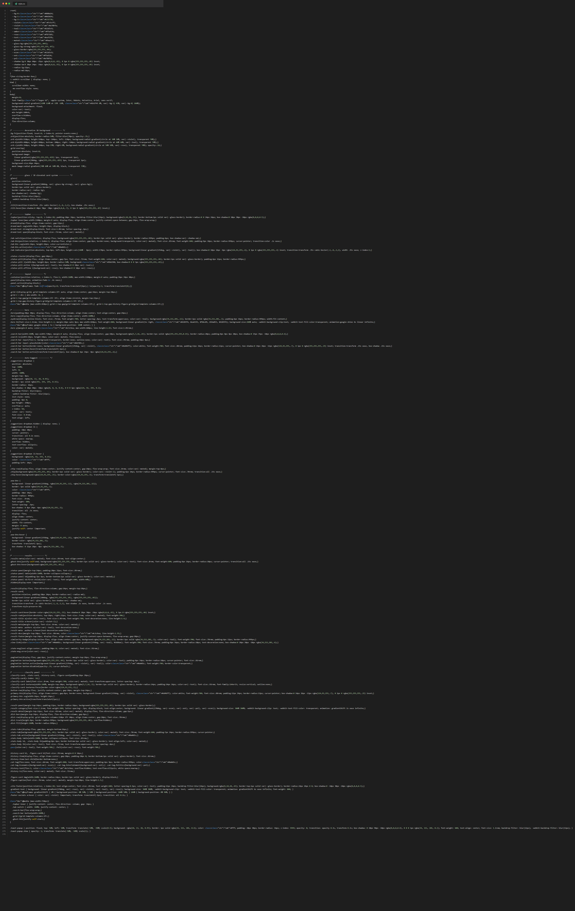
Figure 52. static/css/style.css — CSS Stylesheet

